2021 Technical Advisory Committee Annual Report:  
Abundance, Stock Status, Harvest  
and Endangered Species Act Impacts

Summary of 2020 Fisheries and Fish Runs

Prepared by the *U.S. v Oregon* Technical Advisory Committee

For the  
May 9-10, 2021  
Policy Committee Meeting

Table of Contents

##### List of Tables

##### List of Figures

# Introduction

Fisheries in 2020 operated under the 2018-2027 *U.S. v Oregon* Management Agreement (MA) for the majority of the year[1]. Schedule A of the MA describes the annual schedule for Committee activities for the Technical Advisory Committee (TAC). One of the annual tasks is to provide a summary report describing final post-season (previous year) fishery impacts compared to allowed management limits and objectives described in the MA. This report, through 2020, fulfills that obligation and includes:

* 1. Abundance, harvest, and impacts to upriver stocks of Columbia River salmonids,
  2. Fall Chinook summary report,
  3. Spring Chinook catch balance report,
  4. Endangered Species Act (ESA) impact report, and
  5. Indicator Stock summary report.

Part II.A.1. of the MA addresses catch balancing provisions. The parties will monitor whether the catch balancing expectations have been met by reviewing how actual fisheries compare to the management guidelines described in Table A1 as part of the annual run reconstruction process. As part of the annual process, the states of Oregon and Washington will report fishery mark rate, number of fish retained or landed, number of unclipped and clipped fish[2] released, and stock composition of the mortalities to the parties of *U.S. v Oregon*.

Part II.D. of the MA describes fall Chinook harvest and escapement objectives. TAC’s summary report will include the post-season model output summary (known as Attachment A) describing river mouth abundances, Bonneville Dam passage, and relative harvest rates of upriver fall Chinook and steelhead for treaty and non-treaty fisheries. In addition, escapement data relative to objectives described in the MA will be reported.

In Part I.F.2.a. of the MA, the parties agree to establish performance measures that will be used to monitor progress towards rebuilding the upriver stocks of salmon and steelhead that presently constrain fisheries. Progress towards rebuilding these stocks is measured by tracking trends of the status of specific indicator stocks. Indicator stocks were selected based on geographic distribution and availability of datasets that allowed for establishing a baseline in which to compare future status of these stocks. Two types of indicator stocks have been established: harvest and abundance. Harvest indicator stocks are those used directly for managing fisheries. Abundance indicator stocks were established to provide more detailed information about natural-origin stocks or populations that currently limit fisheries. The status of the indicator stocks will be compared to a 1988-2007 baseline average. The performance measures and baseline data will be used as reference points for gauging progress. TAC is charged with updating the indicator stock data and providing a report to the Policy Committee annually. Pages 19-21 of the MA identify the indicator stocks subject to annual reporting. Part I.F.2.b. of the MA states that if the performance measure of any indicator stock declines for three consecutive years relative to the base period, any party to the MA may request the policy committee to direct TAC to complete an Analysis of Decline. TAC would be given one year to complete the analysis.

# Abundance, Harvest, and Impacts

## Upriver Spring Chinook

The 2018 upriver spring Chinook adult return totaled 115,081 adults to the Columbia River mouth, compared to the forecast of 166,700 adults. Non-treaty fisheries were developed pre-season using catch balancing provisions from the MA. This includes planning non-treaty fisheries based on an abundance decreased by 30% from the pre-season forecast (i.e. run-size buffer) and the associated ESA limit (which in 2020 was a 1.7% natural-origin fish harvest rate limit). Using the buffered run size and the corresponding treaty ESA limit (8.3% natural-origin fish harvest rate limit), the catch balance limit was 9,685 fish prior to the first run size update. This compares to an allowable catch balance limit of 15,170 fish and a non-treaty ESA impact limit of 1.9% if the buffering provision were not in place. The date in 2020 at which 50% of the upriver spring Chinook run had passed Bonneville Dam was one week later than the recent five-year average of May 8, and TAC did not provide the first in-season run size update until May 21. This update estimated a Columbia River mouth run size of 116,500 adults. TAC continued to meet weekly during the spring management period to review the upriver spring Chinook return and maintained the first run-size projection throughout. The post season river mouth run size is estimated at 115,081 adults, which was 69% of the pre-season forecast.

In 2020, the Snake River natural-origin spring Chinook pre-season forecast was 18,500. TAC does not currently have an agreed-to method to update this specific component of the run in-season, therefore TAC presumed that the Snake River natural origin run size would track proportionally to the total run. However, the actual Snake River natural-origin run size was disproportionately lower than forecast and is estimated at 11,339 adults. Since this is less than 10% of the total upriver return the stipulation identified in Footnote 1 of Table A1 in the MA was in effect, which allowed for a total treaty harvest rate of 8.3% and a natural origin harvest rate for non-treaty fisheries of 1.7%.

Post season, treaty fisheries had a 9.5% total harvest rate and a 10.0% natural origin harvest rate. The increased harvest rate on natural-origin fish in treaty fisheries compared to the total harvest rate is due to the proportion of natural origin fish reaching Zone 6 is altered from to the proportion that exists at the river mouth because non-treaty mark-selective fisheries below Bonneville Dam remove a number of hatchery fish thereby increasing the ratio of natural-origin to hatchery-origin fish upstream of Bonneville Dam. ESA limits correspond to the harvest rate limits, and as detailed here tribal fisheries may be up to 0.8% higher on natural origin fish than the total harvest rate because of the effect of non-treaty mark selective fisheries[3]. Treaty fisheries exceeded their allowed impacts in part because of much higher than expected harvest in the last week of the spring platform and hook and line fishery and in part due to the actual run size being less than estimated at the end of the spring management period. ESA impacts from non-treaty fisheries included a 1.2% impact rate on Snake River natural origin spring/summer Chinook (1.7% allowed) and a 0.9% impact rate on Upper Columbia spring natural origin Chinook compared to the 1.7% allowed (Appendix 1).

Post-season, combined treaty and non-treaty actual ESA impacts on Snake River natural origin spring/summer Chinook totaled 11.2% compared to the 10.8%[4] allowed in 2020 and 10.9% on upper Columbia natural origin spring Chinook compared to the same 2020 limit (Appendix 1). This is a result of non-treaty Snake and Upper Columbia impact rates coming in at 1.2% and 0.9% respectively on allowable 1.7% for both, and treaty impact rates coming in at 10% on an allowable 8.3% for both.

Treaty fisheries harvested 10,892 fish (114% of allowed) and non-treaty fisheries accounted for 7,574 fish (79% of allowed). Non-treaty harvest estimates include release mortalities. Upriver Chinook mortalities in treaty and non-treaty fisheries totaled 18,556 fish compared to 19,103 total allowed. See Table 1, Table 2 (a and b), and Table 3 for information provided in this section.

Since 2008, Idaho Department of Fish and Game (IDFG) has calculated the return of Snake River natural origin and hatchery fish to Bonneville Dam using visual and genetic sampling data collected at Lower Granite Dam and conversation rates from Passive Integrated Transponder (PIT)-tagged natural origin and hatchery stocks. When harvest estimates for fisheries downstream of Bonneville Dam are added to the IDFG Bonneville Dam abundance estimates, the Snake River natural-origin and hatchery return at the mouth of the Columbia River differs from those derived using the current TAC methodology. IDFG submitted the method for review by TAC late last year. To date, IDFG?s alternate methodology has not been fully reviewed within TAC. The Snake River natural-origin and hatchery abundances (and calculated impacts) in this report were based on the traditional TAC methodology used to reconstruct the upriver Spring Chinook run.

## Upper Columbia summer Chinook

The 2020 upper Columbia (UC) summer Chinook adult return totaled 42,120 fish to the Columbia River mouth (Table 5), compared to the preseason forecast of 67,300 fish. TAC monitored the run in-season and provided updates beginning July 2 and weekly thereafter. Based on the 2020 actual river mouth return, the post-season ocean harvest estimate of 3,983, and MA Table A2, the number of harvestable fish was much lower than preseason expectations. Postseason, an actual total of 17,103 harvestable fish was to be shared equally (50/50) between treaty and non-treaty fisheries (8,552 each). The non-treaty harvest share includes catch of this stock in all non-treaty PFMC ocean areas and all in-river fisheries. Postseason harvest estimates are 9,498 from treaty fisheries and 10,002 from non-treaty fisheries, including release mortalities (6,019 in-river and 3,983 ocean; Table 4 and Table 5). This indicates combined fishery escapement estimates of this stock were 26,603 adults post season. Both treaty and non-treaty fisheries exceeded the harvest rates allowed in the MA.

## Sockeye

The 2020 sockeye return was 210,915 fish to the Columbia River mouth (Table 7), compared to the preseason forecast of 99,000 fish. Snake River sockeye are the only ESA-listed sockeye within the Columbia River run. The preseason expectation for the Columbia River return of Snake River sockeye was 600 fish, but the actual return was 297 fish using TAC?s standard run reconstruction methods. ESA impact limits allowed for Snake River sockeye based on the MA totaled 8% (Appendix 1). The impacts were allocated 1% to non-treaty fisheries downstream of the mouth of the Snake River and 7% to treaty fisheries. Based on the total allowed impact rate and the actual sockeye return, a total of 16,873 sockeye were available for harvest. Harvestable fish available included 14,764 for treaty fisheries and 2,109 for non-treaty fisheries downstream of the Snake River. Treaty fisheries harvested 7,724 fish (including 3 sockeye during the fall season) and accrued an impact of 3.7%. Non-treaty fisheries downstream of the Snake River accrued 112 sockeye mortalities with an impact of 0.1%. Non-treaty harvest estimates include 32 release mortalities in recreational fisheries. See Table 6 and Table 7.

Sockeye passage totaled 193,816 fish at Bonneville Dam, and 155,480 at McNary Dam (140 miles upriver). According to the Fish Passage Center (FPC_2016_Annual Report, <http://www.fpc.org/documents/annual_FPC_report/>), there is a consistent pattern across years of sockeye adult count disparities when comparing between McNary Dam and Priest Rapids Dam. The total count of sockeye was 189,884 at Priest Rapids Dam. This count disparity indicates that sockeye may migrate through navigation locks when possible.

## Upriver steelhead

TAC accounts for upriver steelhead at Bonneville in three main groups: winter steelhead, Skamania summer steelhead, and A- and B-Index summer steelhead. TAC does not specifically account for steelhead by DPS groups, but rather uses surrogates to estimate impacts to DPSs. Winter steelhead are counted at Bonneville Dam from November 1 through March 31. Winter steelhead are not presumed to occur upstream of The Dalles Dam. At Bonneville Dam, Skamania summer steelhead are counted from April 1 through June 30 and A- and B-Index steelhead are counted from July 1 through October 31. B-index steelhead are defined as any steelhead with a fork length of 78 cm or greater. TAC has recently incorporated methods to estimate the clipped and unclipped components of hatchery origin steelhead.

TAC develops forecasts for upriver Skamania, A-Index, and B-Index summer steelhead returning to Bonneville Dam, unlike most salmon forecasts that are to the river mouth. The 2020 pre-season forecasts for upriver summer steelhead totaled 190,350 fish, including 7,950 (3,000 natural origin) Skamania stock, 158,000 (44,800 natural origin) A-Index, and 24,400 (3,400 natural origin) B-Index. Actual returns were much less than forecasted, with an estimated Bonneville Dam passage total of 100,483 upriver summer steelhead (Table 8). 2020 passage of summer steelhead was 32% of the recent ten-year average. TAC reviewed the return throughout the fall management period and provided multiple in-season updates beginning August 20; it was evident from the onset that the combined A-/B-Index steelhead return was tracking below expectations. TAC will finalize the 2020 Bonneville proportions A-Index and B-Index when the 2020-21 run year analysis is complete at Lower Granite.

Upriver natural origin winter steelhead are included in the forecasts/returns developed by Oregon and Washington. These data measure abundance to the Columbia River mouth. There are no forecasts specific to winter forecasts at Bonneville Dam.

In recent years, TAC has made substantial efforts to refine steelhead harvest accounting to track both treaty and non-treaty harvest in the same categories and avoid issues of either double counting or not including any harvest. Steelhead harvest is separated and tracked in a complex manner by grouping harvest in different areas and different time periods.

### Winter steelhead

Harvest of steelhead from the mouth upstream to Bonneville Dam from November 1 through April 30 are counted as winter steelhead. Harvest of steelhead from November 1 through March 31 between Bonneville Dam and The Dalles Dam are also counted as winter steelhead.

### Skamania summer steelhead

Fisheries from the mouth upstream to Bonneville Dam from May 1 through June 30 are counted as lower river Skamania stock[5]. Fisheries from Bonneville Dam upstream to The Dalles Dam between April 1 and June 30 are counted as upriver Skamania stock.

### A- and B-Index steelhead

Harvest for these two indexes are grouped into two categories. A- and B-Index steelhead harvest is tracked by run year rather than using the calendar year like salmon. TAC considers the run year for these fish to be July 1 of year x through June 30 of year x+1.

### Summer/winter/spring A- and B-Index

Harvest of steelhead in July from the mouth upstream to the Highway-395 Bridge near Pasco, WA is grouped with steelhead harvest from The Dalles Dam upstream to the Highway-395 Bridge from January 1 through June 30 during the following calendar year. This harvest is counted as summer/winter/spring harvest.

### Fall Season A- and B-Index

Harvest of steelhead from Buoy 10 at the mouth of the Columbia upstream to the Highway-395 Bridge from August 1-October 31, and the harvest of steelhead from The Dalles Dam upstream to the Highway-395 Bridge from November 1 through December 31 are counted as fall season harvest. Additionally, ?dip in? impacts for non-local steelhead in certain Zone 6 tributaries is also included in fall season harvest.

The MA only prescribes harvest rate limits on B-Index steelhead in fall season fisheries for treaty fisheries. There are catches and ESA impacts and limits on other groups of steelhead reported later in this document. Fall season harvest rates are based on the Bonneville Dam steelhead run size. Based on MA Table A4, fall season treaty fisheries are limited by an abundance-based harvest rate ranging from 13-20% on the combined hatchery and natural-origin B-Index steelhead run size.

Non-treaty fisheries are managed for a fixed 2% impact rate on natural-origin B-Index steelhead. Non-treaty fisheries also have a 2% impact rate limit on natural-origin A-Index steelhead during the fall season. Treaty fisheries have an expectation of a no more than 12.4% harvest rate on natural-origin A-Index steelhead as specified in the Biological Opinion. Fall season harvest estimates for 2008-2015 are shown in Table 9.

In 2016, TAC began to separate the run into clipped hatchery fish, unclipped hatchery fish, and natural origin fish. 2016 through 2020 fall season harvest estimates are shown in Table 10. In 2020, fall season treaty fisheries harvested 1,301 hatchery and natural-origin B-Index steelhead which was a total harvest rate of 5.3% (13% allowed). The treaty natural-origin harvest rates are based on numbers of unclipped fish harvested divided by the unclipped run sizes; natural origin harvest rates are assumed to be the same as unclipped harvest rates. Fall season non-treaty fisheries resulted in 24 natural origin B-Index mortalities, which equals a natural origin impact rate of 1.0% (2.0% allowed). All 2020 harvest and impact data are preliminary.

## Fall Chinook

The MA prescribes fall season harvest rate limits for Upriver Bright (URB) Chinook, which is only one of the several fall Chinook stocks. The abundance-based harvest rate schedule ranges from 20%-30% for treaty fisheries and from 1.5%-15% for non-treaty fisheries in the mainstem Columbia River downstream of the Snake River. There is a Snake River fall Chinook run size trigger associated with the URB harvest rate schedule as well. The URB harvest rates are a surrogate for Snake River natural origin (SRW) fall Chinook harvest rates. Additionally, the MA contains some fall Chinook management/escapement goals.

The 2020 URB forecast was for a return of 205,060 adult fish to the mouth of the Columbia River. Based on MA Table A3 and the preseason forecast, the allowable URB harvest rate was 45%; allocated 30% to treaty fisheries and 15% to non-treaty fisheries. However, since the forecast was close to a breakpoint on the harvest rate schedule, the states of Oregon and Washington planned non-treaty fisheries to stay within 8.25% prior to an in-season update of URB abundance. The postseason return was 149,043 URBs which was lower than the pre-season forecast (73%). At this run size allowable harvest rate limits were 23% for treaty fisheries and 8.25% for non-treaty fisheries. Passage of URB Chinook at Bonneville Dam totaled 135,120 adult fish. TAC provided several in-season updates for the upriver Chinook components, the first of which was on September 12.

Adult Chinook harvest totaled 22,590 mortalities in combined recreational fisheries and 7,380 in non-treaty commercial fisheries. As of mid-October 2020, in-season accounting of actual and planned impacts for URB Chinook in non-treaty fisheries totaled 8.7% (6.5% recreational and 2.2% commercial). As a result of higher than expected catch rates, post season run-reconstruction analyses resulted in a higher than expected URB Chinook proportion, especially for recreational fisheries, resulting in a post-season inflation of the URB/SRW impacts to 9.35%.

URB harvest totaled 102,680 fish from treaty and non-treaty mainstem fisheries (including Hanford Reach) and had a total harvest rate of 29.6%. Treaty fisheries harvested 30,173 URBs and had a harvest rate of 20.2% when compared to the allowed 23%. Non-treaty fisheries harvested 13,956 URBs in mainstem fisheries and had a URB harvest rate of 9.4% when compared to the allowed 8.25. The SRW harvest rate was for treaty (20.22%) and non-treaty fisheries (9.35%) totaled 29.58% combined. Table 11 contains harvest impacts on URB and SRW fall Chinook. See Appendix 2 for the 2020 post-season fall Chinook model summary page.

### Escapement/Management Goals

The management goal of 60,000 URBs at McNary was greatly exceeded, with 100,026 adult Chinook counted during the fall season. The broodstock escapement goal of 7,000 adult fall Chinook (4,000 females) at Spring Creek NFH was met. Combined treaty and non-treaty impacts on upriver fall Chinook remained within ESA limits although non-treaty fisheries exceeded their allowed impacts on SRW Chinook. MA escapement objectives were met. TAC has provided a preliminary post-season model summary for all stocks in Appendix 2. A detailed summary of 2020 treaty and non-treaty fall season fisheries will be provided in the 2019 Fall Joint Staff Report which will be available by the end of August.

### Fall Chinook Harvestable Surplus

The MA contains a provision that non-treaty ocean and in-river fisheries may not harvest more than 50% of the harvestable surplus of upriver fall Chinook, with non-treaty and treaty totaling 37% and 42%, respectively. The stocks currently included in the upriver allocation are Upriver Brights (URB), Pool Upriver Brights (PUB), and Bonneville Pool Hatchery tules (BPH ? Spring Creek). Table 12 shows the harvestable surplus calculations since 2008. TAC has not received final ocean harvest estimates by stock for 2008 fisheries, so the ocean harvest shown for that year are final in-season estimates.

In 2020, a total of 213,913 adult upriver (URB, PUB, BPH) fall Chinook entered the Columbia River mouth. A total of 145,079 adult upriver fall Chinook were harvested in treaty (55,856) and non-treaty (50,424) fisheries. These totals include all non-treaty ocean, Columbia River mainstem, and Columbia River tributary fisheries except for those fisheries in the lower Snake River and upstream of Lower Granite Dam which were not available for this report. These calculations are not converted to Bonneville equivalents. These data are based on the run reconstruction completed by WDFW and provided to TAC and are considered preliminary.

## Upriver Coho

The 2020 ocean abundance of Columbia River coho destined for areas upstream of Bonneville Dam was 67,226 fish. Non-treaty ocean harvest in the PFMC area was 16,901. When combined with in-river commercial and recreational harvest, including the Buoy 10 fishery the total non-treaty harvest of upriver coho was 26,338. The Bonneville Dam passage totaled 40,888 adult fish (Table 13). An estimated 60.8% of the abundance of upriver Columbia River coho passed Bonneville Dam, compared to the requirement in the MA of 50%. Table 13 shows the percent of the upriver coho harvested since 2008. The catch estimates for upriver coho are made by WDFW and/or NMFS staff using methods that have not been fully documented or reviewed by TAC. The estimates are provided to TAC annually through a spreadsheet known as ?Attachment C?, which contains output from FRAM ocean fishery modeling.

# Spring Season Catch Balancing

The 2020 treaty and non-treaty winter/spring mainstem and lower Snake River fisheries accounted for 18,556 fish harvested compared to 19,103 allowed (Table 1). Catch balancing allowed for 9,552 fish each for treaty and non-treaty fisheries. Treaty fisheries caught 10,892 fish (114% allowed, 59% of the total harvested) and non-treaty fisheries harvested 7,574 fish (79% allowed, 41% of the total). Non-treaty harvest estimates include release mortalities. Additionally, 2020 pre-run-update non-treaty fisheries remained within the impact limit allowed under the 30% run size buffer.

# ESA Impact Report

In 2020, Columbia River treaty and non-treaty fisheries combined met all ESA limits except for Snake River spring/summer Chinook, upper Columbia spring Chinook and the fall bright component of the Lower Columbia Chinook ESU. Treaty spring Chinook catches at the end of the spring management period were higher than expected and the post season run reconstruction resulted in a smaller actual run size than was projected at the end of the spring management period. The non-treaty Snake and Upper Columbia impact rates were 1.2% and 0.9% respectively on allowable 1.7% for both, and treaty impact rates were 10% each on an allowable 8.3% for both. The non-treaty impacts on Snake River natural-origin fall Chinook were exceeded, but the combined treaty and non-treaty impacts on Snake River natural-origin fall Chinook were within the allowed limits. Appendix 1 reports ESA impacts for mainstem fisheries. Appendix 2 reports ESA impacts for treaty tributary fisheries included in the Biological Opinion. Appendix 3 reports ESA impacts for Research and Monitoring and Evaluation programs. Following are the impacts on listed salmonids covered in the Biological Opinion, but not specified in the MA:

## Lower Columbia Chinook ESU

### Spring Chinook

Fisheries are currently managed for hatchery escapement. Spring Chinook hatchery escapement goals for Sandy River Hatchery, Lewis River Hatchery, Cowlitz River Hatchery, and Kalama Falls Hatchery were met

### Tule fall Chinook

The exploitation rate (ER) limit for natural origin lower river tule fall Chinook from ocean and in-river fisheries is established by an abundance-based management framework. Preseason the allowed ER was 38%.The actual ocean and non-treaty in-river ER totaled 34.5%, which is 91% of allowed.

### Bright fall Chinook

The fall bright component of the lower Columbia River Chinook ESU is managed for a natural spawning escapement goal of 5,700 adult fish to the North Fork Lewis River. The total adult escapement to the North Fork Lewis River in 2020 was estimated to be 6,960 fish, including 1,760 LRH stock and 5,200 LRW stock.

## Willamette Spring Chinook ESU

For the Willamette spring Chinook ESU, there is a 15% natural origin harvest rate limit for mainstem Columbia River and Willamette River (downstream of Willamette Falls) fisheries. 2020 fisheries remained well within the 15% limit, at 6.1% (Appendix 1).

## Winter Steelhead

TAC continues to discuss and review methods for accounting for steelhead harvest. Refinements to harvest accounting are currently being developed. Winter steelhead are counted at Bonneville Dam from November 1 through March 31. Winter steelhead are not presumed to occur upstream of The Dalles Dam. TAC does not forecast the winter steelhead return to Bonneville Dam nor does the MA specify harvest rate limits on winter steelhead above Bonneville Dam. Non-treaty fisheries conducted during the winter season incidentally handle natural-origin winter steelhead while targeting hatchery Chinook or hatchery steelhead. When lower Columbia and upper Willamette steelhead were listed under the federal ESA, a 2% annual impact rate for all non-treaty mainstem fisheries combined was established in the BOs for mainstem fisheries. Non-treaty fisheries have remained well below the ESA impact limits allowed for mainstem fisheries. See Table 14, Table 15, and Table 16 for harvest and impact details.

The Columbia River natural-origin winter steelhead return for the run year (November 2017 through April 2020) totaled 11,323 fish. A total of 28 natural-origin winter steelhead mortalities (all from release mortality) occurred in non-treaty fisheries downstream of Bonneville Dam. This includes fisheries in April since there are still lower river winter run steelhead in this lower section of river; passage of steelhead at Bonneville Dam in April are considered summer steelhead. 2017-18 winter season non-treaty sport fisheries had 2 mortalities on natural-origin winter steelhead in the Bonneville Pool. Total incidental release mortalities from non-treaty mainstem fisheries are estimated at 29 fish, resulting in an impact rate of 0.3% compared to the 2% limit (Table 14). There were 54 unclipped winter steelhead harvested in tribal fisheries in 2017-18 winter season fisheries in the Bonneville Pool (November?March, Table 16). This resulted in a natural origin impact rate of 5.6% using the Bonneville Dam run size, or an impact rate of 0.5% using the Columbia River mouth run size.

## Summer Steelhead

Non-treaty fisheries are allowed a 2% natural origin impact rate in summer (July) plus the following winter and spring (January 1 through June 30) fisheries for ESA-listed natural origin A- and B-Index summer steelhead groups. An additional 2% natural origin impact rate is allowed in fall (August-December) fisheries. Non-treaty fisheries also have a 2% natural origin impact limit for lower river Skamania stock steelhead and a 2% limit for natural origin upriver Skamania stock steelhead in the Bonneville Pool. Treaty fisheries do not have a harvest rate limit for spring and summer season fisheries, but there is an expectation that treaty fisheries would be within a 4.1-12.4% natural origin harvest rate. See Table 17, Table 18 and Table 19 for harvest and impact details for winter, spring, and summer fisheries. Fall season harvest and impacts on summer steelhead are reported in Table 9 and Table 10.

In 2020 spring and early summer treaty fisheries through June 30, the harvest was 146 steelhead (33 unclipped steelhead) in the Bonneville Pool and Drano Lake from March 22 until June 30, 2020 (Table 17), which resulted in an unclipped Skamania steelhead harvest rate of 1.14%. The 2017 summer and 2020 winter/spring treaty commercial mainstem fisheries upstream of The Dalles Dam harvested 323 A-/B-Index summer steelhead (76 unclipped A-Index and 46 unclipped B-Index steelhead) that are counted against the 2019-2020 run year (Table 17 and Table 18), and therefore had a 0.3% natural-origin harvest rate on A-Index and a 0.8% harvest rate on natural origin B-Index steelhead.

In the 2020 fall season fisheries the treaty harvest rate is based on the 2020-2021 run year. The treaty harvest rate on the various natural-origin stocks in the 2020 fall management period was 4.5% and 5.7% on A-Index and B-Index groups respectively (Table 10).

In 2020, winter and spring season non-treaty fisheries incurred a total of 64 release mortalities on natural-origin lower Columbia Skamania (L-Ska) summer steelhead resulting in an impact of 0.7% (2.0% impact limit). The non-treaty fisheries had 0 impacts on natural-origin upriver Skamania stock fish in the 2020 fisheries in Bonneville Pool (Table 20). The non-treaty fisheries that occurred in the winter and spring of 2020 upstream of The Dalles Dam had 296 total for natural- and hatchery-origin A-/B-Index mortalities which are counted toward the A-/B-Index summer steelhead run year 2019-2020 (Table 21). Any steelhead harvest or incidental mortalities from the WDFW Snake River fisheries that occur in the spring season of 2020 are also counted as A-/B-Index summer steelhead run year 2019-2020; it was estimated that no more than 0 steelhead were killed in 2020 as the fishery was much smaller than typical (Table 22). The summer management period non-treaty fisheries had 144 mortalities (all release mortality) on natural-origin A-Index steelhead (Table 23). Summer season non-treaty fisheries (Table 23) incurred a total of 2 natural-origin B-Index release mortalities.

## Chum

There is a 5% harvest rate limit on chum in non-treaty fisheries. Non-treaty fisheries (recreational and commercial) in 2020 were prohibited from retaining chum, and no mainstem commercial fisheries occurred after August, therefore the estimated harvest rate was 0% (Appendix 1). Treaty fisheries do not harvest chum downstream of Bonneville and there are not significant chum populations in the Bonneville Pool. No chum were counted at Bonneville Dam prior to the conclusion of treaty fall season gillnet fisheries and the late fall platform fishery has relatively low effort. No harvest of chum was identified in the treaty fishery in 2020.

## Coho

A harvest-rate matrix is used to determine the allowable ER on lower Columbia River coho in non-treaty ocean and in-river fisheries. The current matrix was adopted in 2015. Given the criteria for the harvest rate matrix, the allowed ER on coho was 18% for 2020 non-treaty fisheries. Based on post-season modeling of ocean and in-river fisheries the actual LCN ER was 11.1% (Appendix 1); of this in-river fisheries accrued 1.7% (15.5% of the total). The harvest estimate for coho in the Bonneville Pool was 2,098 fish which equates to a 5.1% harvest rate on the Bonneville run size. This harvest rate is presumed to be the maximum harvest rate on LCR coho in the Bonneville Pool.

## Treaty Tributary Fisheries

Natural-origin steelhead impacts in treaty tributary fisheries outside the Snake Basin are shown in Table 25 through Table 32. Treaty Spring Chinook harvest in the Hood River is shown in Table 27.

At this time, there are no recorded natural origin steelhead harvest impacts in the Hood River, in spring season fisheries in the Deschutes River, or in the John Day River. Treaty fisheries were not open in the Walla Walla River in 2020.

## Research Impacts

The Incidental Take Statement for the Biological Opinion provides for a small amount of impacts reserved for research, monitoring, and evaluation purposes. For the Chinook and coho ESUs, the allowed range of impacts is 0.1-0.5%. For steelhead DPSs and sockeye and chum ESUs, the allowed range of impacts is 0.1-0.3%. In 2020, research impacts were used by CRITFC for monitoring fish at the Bonneville AFF (adult trap), by WDFW for spring pre-fishery test fishing, and by ODFW for monitoring/evaluation of white sturgeon populations downstream of Bonneville and in Zone 6 and alternative gear testing of a seine net by WDFW and a pound net by the Wild Fish Conservancy.

Sampling at the Bonneville AFF causes a small number of direct mortalities and an assumed very small number of indirect mortalities from handing fish. Direct mortalities may be from fish which die during sampling, but are primarily mortalities discovered in the AFF after sampling concludes. Table 33 shows direct mortalities from 2008 through 2020 due to CRITFC sampling. At times, other sampling has been occurring at the AFF and these mortalities could possibly have been from other projects as well. In 2020, three direct mortalities were observed, including one summer Chinook, one fall Chinook, and one sockeye. The summer Chinook would not be an ESA-listed fish. Because of low sample rates (normally less than 1% of the run) and a low percentage of ESA-listed fish in the run, it is unlikely any of the direct mortalities were ESA listed fish.

Sample rates at the AFF are generally less than 1% for any run. The impact rates for the AFF during 2008-2020 have been well under 0.005 (Table 33 through Table 36).

Chinook, steelhead, and chum impacts from various ODFW/WDFW research fishing were within the expected range. Table 37 through Table 42 summarize the actual impact rates across 2008-2020 for the test fishery and sturgeon research monitoring.

Finally, there were research activities in 2020 related to alternative gear testing. The research testing using pound nets was conducted in the Cathlamet Channel on the Washington shore from August 25 ? October 31, 2020. Adult handle during that time included 1513 Chinook (600 kept + 913 released), 912 coho (450 kept + 462 released), and 307 steelhead (307 released). Release mortality rates for Chinook and coho were assumed to be 14.6% and 6% for steelhead, based on a cursory TAC review of provisional analyses made available by the Wild Fish Conservancy after the 2017 Pound Net study. Estimated mortalities from this work include 8 unclipped LRH, 0 LRW, and 227 URB mortalities, 68 Lower Columbia Natural coho mortalities, and 4 wild A/B steelhead (2.3 A-Index, 1.3 B-Index, 0.4 unknown) mortalities. Resulting impact rates (percent of final run-size) were 0.016% LRH, 0.000% LRW, 0.152% URB for Chinook; 0.229% LCN coho; and 0.017% for A/B steelhead (0.011% A-Index, 0.054% B-Index).

We have summarized total impacts for all research activities from 2008-2020 in Table 32 through Table 45 and in Appendix 3. All impacts were under the impact guidelines[6].

# Summary of Harvest and Abundance Indicator Stocks

As identified in the MA, harvest indicator stocks are those used directly for managing fisheries and abundance indicator stocks were established to provide more detailed information about natural-origin stocks or populations that currently limit fisheries. The status of the indicator stocks will be compared to a 1988-2007 baseline average. The performance measures and baseline data will be used as reference points for gauging progress. Summary data are shown in Tables 46-50 and Figures 1-7.

Several harvest and abundance indicator groups of fish showed a decline over the recent three years. Some 2020 abundance are lower than base period values, while others are greater. TAC has provided graphs illustrating recent years relative to the base period.

2017-18 data should be considered preliminary or incomplete (ongoing) for Snake River steelhead.

Table . Harvest accounting for upriver spring Chinook (including Snake River summer Chinook), 2009–2018.

| Year | River Mouth Run Size | Total Non-treaty Impacts | Total Treaty Impacts | Total Allowed Treaty Harvest Rate | Total Allowed Treaty Harvest (catch balance for non-treaty) | Total Actual Treaty Harvest Rate |
| --- | --- | --- | --- | --- | --- | --- |
| 2009 | 169,296 | 20,809 | 13,101 | 0.091 |  | 7.7% |
| 2010 | 315,346 | 38,298 | **42,954** | 0.108 | 34,057 | **13.6%** |
| 2011 | 221,158 | 17,752 | 15,533 | 0.100 | 22,116 | 7.0% |
| 2012 | 203,090 | 18,723 | 17,701 | 0.091 | 18,481 | 8.7% |
| 2013 | 123,136 | 8,557 | 9,282 | 0.083 | 10,220 | 7.5% |
| 2014 | 242,635 | 23,020 | **24,703** | 0.100 | 24,263 | **10.2%** |
| 2015 | 288,994 | 25,495 | 31,181 | 0.108 | 31,211 | 10.8% |
| 2016 | 187,816 | 16,022 | 17,066 | 0.091 | 17,091 | 9.1% |
| 2017 | 115,821 | 7,779 | **8,109** | 0.070 | 8,107 | **7.0%** |
| 2018 | 115,081 | 7,536 | **10,892** | 0.083 | 9,552 | **9.5%** |
| Note: bold values indicate overage. | | | | | | |

Table . Harvest of natural origin upper Columbia spring Chinook, 2009–2018.

| Year | River Mouth Run Size | Non-treaty Harvest Impacts | Treaty Harvest Impacts | Allowed Non-treaty Harvest Rate | Allowed Treaty Harvest Rate1 | Total Allowed Harvest Rate1 | Actual Non-treaty Harvest Rate | Actual Treaty Harvest Rate | Actual Total Wild Harvest Rate |
| --- | --- | --- | --- | --- | --- | --- | --- | --- | --- |
| 2009 | 1,101 | 20 | 94 | 1.9% | 9.1-9.9% | 11.8% | 1.8% | 8.6% | 10.4% |
| 2010 | 3,110 | 62 | 461 | 2.2% | 10.8-11.6% | 13.8% | 2.0% | 14.8% | 16.8% |
| 2011 | 2,659 | 37 | 195 | 2.0% | 10.0-10.8% | 12.8% | 1.4% | 7.3% | 8.7% |
| 2012 | 5,871 | 73 | 545 | 1.9% | 9.1-9.9% | 11.8% | 1.2% | 9.3% | 10.5% |
| 2013 | 3,475 | 47 | 272 | 1.7% | 8.3-9.1% | 10.8% | 1.4% | 7.8% | 9.2% |
| 2014 | 6,287 | 105 | 680 | 2.0% | 10.0-10.8% | 12.8% | 1.7% | 10.8% | 12.5% |
| 2015 | 7,246 | 141 | 831 | 2.2% | 10.8-11.6% | 13.8% | 1.9% | 11.5% | 13.4% |
| 2016 | 5,111 | 85 | 491 | 1.9% | 9.1-9.9% | 11.8% | 1.7% | 9.6% | 11.3% |
| 2017 | 2,527 | 33 | 189 | 1.5% | 7.0-7.8% | 9.3% | 1.3% | 7.5% | 8.8% |
| 2018 | 1,974 | 18 | 197 | 1.7% | 8.3-9.1% | 10.8% | 0.9% | 10.0% | 10.9% |
| 1Incidental Take Statement presumes treaty wild harvest rates may be up to 0.8% higher than allowed total harvest rates. | | | | | | | | | |

Table . Harvest of natural origin Snake River spring/summer Chinook, 2009–2018.

| Year | River Mouth Run Size | Non-treaty Harvest Impacts | Treaty Harvest Impacts | Allowed Non-treaty Harvest Rate | Allowed Treaty Harvest Rate1 | Total Allowed Harvest Rate1 | Actual Non-treaty Harvest Rate | Actual Treaty Harvest Rate | Actual Total Wild Harvest Rate |
| --- | --- | --- | --- | --- | --- | --- | --- | --- | --- |
| 2009 | 20,513 | 339 | 1,758 | 1.9% | 9.1-9.9% | 11.8% | 1.7% | 8.6% | 10.2% |
| 2010 | 34,899 | 659 | 5,169 | 2.2% | 10.8-11.6% | 13.8% | 1.9% | 14.8% | 16.7% |
| 2011 | 30,757 | 452 | 2,260 | 2.0% | 10.0-10.8% | 12.8% | 1.5% | 7.3% | 8.8% |
| 2012 | 35,510 | 485 | 3,294 | 1.9% | 9.1-9.9% | 11.8% | 1.4% | 9.3% | 10.6% |
| 2013 | 22,481 | 311 | 1,757 | 1.7% | 8.3-9.1% | 10.8% | 1.4% | 7.8% | 9.2% |
| 2014 | 45,993 | 780 | 4,973 | 2.0% | 10.0-10.8% | 12.8% | 1.7% | 10.8% | 12.5% |
| 2015 | 30,193 | 573 | 3,463 | 2.2% | 10.8-11.6% | 13.8% | 1.9% | 11.5% | 13.4% |
| 2016 | 23,635 | 395 | 2,270 | 1.9% | 9.1-9.9% | 11.8% | 1.7% | 9.6% | 11.3% |
| 2017 | 7,204 | 80 | 540 | 1.5% | 7.0-7.8% | 9.3% | 1.1% | 7.5% | 8.6% |
| 2018 | 11,339 | 134 | 1,132 | 1.7% | 8.3-9.1% | 10.8% | 1.2% | 10.0% | 11.2% |
| 1Incidental Take Statement presumes treaty wild harvest rates may be up to 0.8% higher than allowed total harvest rates. | | | | | | | | | |

Table . 2020 total mainstem spring Chinook harvest and release mortalities.

|  | Zones 1-5 | | | | | |  | Zone 6 | |  |  |  |
| --- | --- | --- | --- | --- | --- | --- | --- | --- | --- | --- | --- | --- |
| Stock | Non-tribal Commercial Mainstem | Commercial Select Areas | Sport | Sport Select Areas | Test | Treaty Tribal2 |  | Sport3 | Treaty Tribal | Wanapum Tribal | Snake River Sport | Total Harvest or Impact |
| Lower Columbia and Willamette1 | 0 | 16,853 | 1,943 | 1,339 | 228 | 0 |  | 0 | 0 | 0 | 0 | 20,363 |
| Upriver stocks | 0 | 463 | 7,198 | 0 | 620 | 16 |  | 18 | 8,093 | 35 | 66 | 16,509 |
| Total | 0 | 17,316 | 9,141 | 1,339 | 848 | 16 |  | 18 | 8,093 | 35 | 66 | 36,872 |
| Snake River Wild | 0 | 25 | 43 | 0 | 0 | 3 |  | 1 | 466 | 0 | 1 | 539 |
| Upper Columbia Wild | 0 | 10 | 17 | 0 | 0 | 1 |  | 1 | 187 | 6 | 0 | 222 |
| 1Lower Columbia and Willamette Stocks do not count towards treaty non-treaty allocation or catch balance. | | | | | | | | | | | | |
| 2Includes fish donated from test fisheries. | | | | | | | | | | | | |
| 3Zone 6 value includes any 'upper Columbia sport' | | | | | | | | | | | | |

Table . 2018 harvest impact details for upper Columbia summer Chinook.

|  | Ocean |  | Zones 1-5 | | |  |  |  |  |  |  |
| --- | --- | --- | --- | --- | --- | --- | --- | --- | --- | --- | --- |
| Year | PFMC Area Non-treaty Sport and Commercial |  | Non-treaty Commercial (mainstem and select areas) | Sport | Treaty | Sport BON to PRD | Zone 6 Treaty | Upper Columbia Sport | Wanapum Tribal | Colville Tribal | Total Harvest Impact |
| 2018 | 3,983 |  | 24 | 1,140 | 50 | 134 | 9,448 | 3,385 | 68 | 1,268 | 19,500 |

Table . Upper Columbia summer Chinook harvest, 2009–2018.

| Year | PFMC Area Ocean Abundance | PFMC Area Non-treaty HJarvest | River Mouth Run Size | Total Non-treaty In-river Impacts | Total Non-treaty Impacts | Total Treaty Impacts | Allowed Harvest (for either treaty or non-treaty) | Allowed Harvest Rate (for either treaty or non-treaty) | Total Actual Non-treaty Harvest Rate | Total Actual Treaty Harvest Rate |
| --- | --- | --- | --- | --- | --- | --- | --- | --- | --- | --- |
| 2009 | 55,910 | 2,029 | 53,881 | 8,985 | 11,014 | 11,650 | 12,716 | 22.7% | 19.7% | 20.8% |
| 2010 | 72,394 | 48 | 72,346 | 14,417 | 14,465 | 15,799 | 18,898 | 26.1% | 20.0% | 21.8% |
| 2011 | 83,742 | 3,168 | 80,574 | 17,777 | 20,946 | 20,645 | 23,153 | 27.6% | 25.0% | 24.7% |
| 2012 | 62,475 | 4,175 | 58,300 | 12,695 | 16,870 | 7,824 | 15,178 | 24.3% | **27.0%** | 12.5% |
| 2013 | 70,492 | 2,889 | 67,603 | 10,960 | 13,846 | 13,397 | 18,185 | 25.8% | 19.6% | 19.0% |
| 2014 | 86,989 | 8,735 | 78,254 | 12,225 | 20,960 | 19,389 | 24,371 | 28.0% | 24.1% | 22.3% |
| 2015 | 133,203 | 6,321 | 126,882 | 26,497 | 32,819 | 37,763 | 41,701 | 31.3% | 24.6% | 28.4% |
| 2016 | 94,443 | 3,395 | 91,048 | 15,293 | 19,129 | 20,515 | 27,166 | 28.8% | 20.3% | 21.7% |
| 2017 | 75,516 | 7,312 | 68,204 | 10,284 | 17,535 | 16,328 | 20,069 | 26.6% | 23.2% | 21.6% |
| 2018 |  |  | 42,120 | 6,170 | 10,002 | 9,498 |  |  |  |  |
| Note: any bold values indicate overage. | | | | | | | | | | |

Table . 2020Sockeye harvest accounting.

|  | Zones 1-5 | | |  |  |  |  |  |  |  |  |
| --- | --- | --- | --- | --- | --- | --- | --- | --- | --- | --- | --- |
|  | Commercial (includes select areas) | Sport | Treaty | Zone 6 Sport | Zone 6 Tribal | Upper Columbia Sport (upstream of Snake) | Wanapum | Colville | Total Non-treaty | Total Treaty | Total Harvest |
| Columbia River Sockeye | 6 | 105 | 40 | 1 | 7,684 | 17,343 | 234 | 11,224 | 28,913 | 7,724 | 36,637 |
| Snake River Sockeye | 0.0 | 0.1 | 0.1 | 0.0 | 10.8 | 0.0 | 0.0 | 0.0 | 0.2 | 10.8 | 11.0 |

Table . Sockeye harvest, 2009–2018.

| Year | River Mouth Run Size | Total Non-treaty Harvest (downstream of Snake R.) | Total Treaty Harvest | Total Harvest Downstream of Snake R. | Total Non-treaty Harvest Rate1 | Total Treaty Harvest Rate2 | Total Non-treaty Harvest Upstream of Snake R.3 | Total Non-treaty Harvest |
| --- | --- | --- | --- | --- | --- | --- | --- | --- |
| 2009 | 179,732 | 1,186 | 9,731 | 10,918 | 0.7% | 5.4% | 21,508 | 22,695 |
| 2010 | 392,193 | 468 | 26,125 | 26,593 | 0.1% | 6.7% | 32,707 | 33,175 |
| 2011 | 187,365 | 1,873 | 12,853 | 14,726 | 1.0% | 6.9% | 2,958 | 4,831 |
| 2012 | 521,159 | 5,456 | **45,352** | 50,808 | 1.0% | **8.7%** | 62,535 | 67,991 |
| 2013 | 186,191 | 708 | 8,049 | 8,757 | 0.4% | 4.3% | 22,365 | 23,073 |
| 2014 | 651,146 | 1,708 | 30,702 | 32,410 | 0.3% | 4.7% | 70,574 | 72,282 |
| 2015 | 512,455 | 1,487 | 30,095 | 31,582 | 0.3% | 5.9% | 76,917 | 78,404 |
| 2016 | 356,606 | 1,190 | 16,683 | 17,873 | 0.3% | 4.7% | 38,835 | 40,025 |
| 2017 | 88,263 | 414 | 4,480 | 4,894 | 0.5% | 5.1% | 7,823 | 8,237 |
| 2018 | 210,915 | 106 | 7,724 | 7,830 | 0.1% | 3.7% | 28,801 | 28,907 |
| Note: bold values indicate overage. | | | | | | | | |
| 11% allowed. | | | | | | | | |
| 27% allowed. | | | | | | | | |
| 3Non-treaty harvest upstream of the Snake River is not included in the non-treaty harvest rate limit because it does not impact Snake River fish. | | | | | | | | |

Table . 2020 upriver summer steelhead forecast and returns to Bonneville Dam.

|  | Forecast | Actual Return |
| --- | --- | --- |
| **Skamania** | **7,950** | **6,483** |
| Total Hatchery | 4,950 | 3,888 |
| Clip Hatchery | 4,650 | 3,629 |
| Unclip Hatchery | 300 | 259 |
| Natural Origin | 3,000 | 2,595 |
| **A-Index** | **158,000** | **69,338** |
| Total Hatchery | 113,200 | 47,613 |
| Clip Hatchery | 107,000 | 45,430 |
| Unclip Hatchery | 6,200 | 2,183 |
| Natural Origin | 44,800 | 21,725 |
| **B-Index** | **24,400** | **24,662** |
| Total Hatchery | 21,000 | 22,280 |
| Clip Hatchery | 17,700 | 19,056 |
| Unclip Hatchery | 3,300 | 3,224 |
| Natural Origin | 3,400 | 2,382 |
| **Total A/B Index** | **182,400** | **94,000** |
| Total Hatchery | 134,200 | 69,893 |
| Clip Hatchery | 124,700 | 64,486 |
| Unclip Hatchery | 9,500 | 5,407 |
| Natural Origin | 48,200 | 24,107 |
| **All summer steelhead** | **190,350** | **100,483** |
| Total Hatchery | 139,150 | 73,781 |
| Clip Hatchery | 129,350 | 68,115 |
| Unclip Hatchery | 9,800 | 5,666 |
| Natural Origin | 51,200 | 26,702 |

Table . Fall season steelhead harvest impacts, 2008-2016.

| **Hatchery A steelhead** | |  |  |  |  |  |  |  |  |
| --- | --- | --- | --- | --- | --- | --- | --- | --- | --- |
| Year | Non-treaty Commercial | Zone 1-5 Sport | Bonneville Dam Run | Treaty | Zone 6-Hwy 395 Sport | Total Non-treaty | Total Non-treaty Harvest Rate | Total Treaty | Treaty Harvest Rate |
| 2008 | 386 | 2,026 | 162,829 | 8,503 | 8,033 | 10,445 | 6.4% | 8,503 | 5.2% |
| 2009 | 740 | 7,049 | 391,129 | 21,340 | 28,261 | 36,050 | 9.2% | 21,340 | 5.5% |
| 2010 | 460 | 5,090 | 178,194 | 9,835 | 10,982 | 16,532 | 9.3% | 9,835 | 5.5% |
| 2011 | 921 | 11,191 | 206,493 | 12,657 | 14,193 | 26,305 | 12.7% | 12,657 | 6.1% |
| 2012 | 418 | 5,126 | 120,977 | 7,256 | 10,216 | 15,759 | 13.0% | 7,256 | 6.0% |
| 2013 | 356 | 6,045 | 120,697 | 9,401 | 10,585 | 16,986 | 14.1% | 9,401 | 7.8% |
| 2014 | 527 | 5,870 | 152,505 | 11,143 | 11,378 | 17,775 | 11.7% | 11,143 | 7.3% |
| 2015 | 417 | 4,124 | 152,902 | 8,901 | 16,976 | 21,517 | 14.1% | 8,901 | 5.8% |
| 2016 | 458 | 1,371 | 92,225 | 6,164 | 5,529 | 7,358 | 8.0% | 6,164 | 6.7% |

| **Wild A steelhead1** | |  |  |  |  |  |  |  |  |
| --- | --- | --- | --- | --- | --- | --- | --- | --- | --- |
| Year | Non-treaty Commercial | Zone 1-5 Sport | Bonneville Dam Run | Treaty | Zone 6-Hwy 395 Sport | Total Non-treaty | Total Non-treaty Harvest Rate | Total Treaty | Treaty Harvest Rate |
| 2008 | 141 | 99 | 80,089 | 3,645 | 278 | 519 | 0.6% | 3,645 | 4.6% |
| 2009 | 239 | 412 | 153,068 | 7,948 | 886 | 1,537 | 1.0% | 7,948 | 5.2% |
| 2010 | 210 | 276 | 120,328 | 4,816 | 449 | 935 | 0.8% | 4,816 | 4.0% |
| 2011 | 292 | 731 | 116,755 | 6,876 | 588 | 1,610 | 1.4% | 6,876 | 5.9% |
| 2012 | 142 | 308 | 70,412 | 4,225 | 324 | 773 | 1.1% | 4,225 | 6.0% |
| 2013 | 208 | 645 | 93,281 | 6,149 | 578 | 1,430 | 1.5% | 6,149 | 6.6% |
| 2014 | 335 | 514 | 110,951 | 8,453 | 700 | 1,549 | 1.4% | 8,453 | 7.6% |
| 2015 | 172 | 258 | 85,158 | 5,384 | 742 | 1,172 | 1.4% | 5,384 | 6.3% |
| 2016 | 147 | 83 | 36,665 | 3,141 | 122 | 352 | 1.0% | 3,141 | 8.6% |
| 1Wild catch includes all unclipped fish and is not adjusted for unclipped hatchery origin fish. This overestimates wild harvest rates. | | | | | | | | | |

Table 10. Fall season steelhead harvest impacts, 2008-2016 (cont.).

| **Hatchery B steelhead** | |  |  |  |  |  |  |  |  |
| --- | --- | --- | --- | --- | --- | --- | --- | --- | --- |
| Year | Non-treaty Commercial | Zone 1-5 Sport | Bonneville Dam Run | Treaty | Zone 6-Hwy 395 Sport | Total Non-treaty | Total Non-treaty Harvest Rate | Total Treaty | Treaty Harvest Rate |
| 2008 | 270 | 562 | 76,246 | 11,518 | 4,863 | 5,695 | 7.5% | 11,518 | 15.1% |
| 2009 | 68 | 276 | 28,834 | 5,354 | 5,976 | 6,320 | 21.9% | 5,354 | 18.6% |
| 2010 | 210 | 954 | 60,073 | 9,809 | 5,237 | 6,401 | 10.7% | 9,809 | 16.3% |
| 2011 | 236 | 862 | 24,473 | 5,547 | 2,907 | 4,004 | 16.4% | 5,547 | 22.7% |
| 2012 | 65 | 492 | 18,464 | 2,462 | 3,542 | 4,100 | 22.2% | 2,462 | 13.3% |
| 2013 | 34 | 94 | 8,348 | 1,097 | 1,274 | 1,402 | 16.8% | 1,097 | 13.1% |
| 2014 | 119 | 505 | 30,827 | 3,753 | 3,162 | 3,787 | 12.3% | 3,753 | 12.2% |
| 2015 | 55 | 88 | 9,590 | 1,484 | 2,137 | 2,280 | 23.8% | 1,484 | 15.5% |
| 2016 | 72 | 491 | 33,839 | 2,897 | 4,354 | 4,916 | 14.5% | 2,897 | 8.6% |

| **Wild B steelhead1** | |  |  |  |  |  |  |  |  |
| --- | --- | --- | --- | --- | --- | --- | --- | --- | --- |
| Year | Non-treaty Commercial | Zone 1-5 Sport | Bonneville Dam Run | Treaty | Zone 6-Hwy 395 Sport | Total Non-treaty | Total Non-treaty Harvest Rate | Total Treaty | Treaty Harvest Rate |
| 2008 | 63 | 22 | 20,088 | 2,673 | 144 | 229 | 1.1% | 2,673 | 13.3% |
| 2009 | 29 | 26 | 14,704 | 2,112 | 278 | 334 | 2.3% | 2,112 | 14.4% |
| 2010 | 77 | 64 | 22,552 | 2,992 | 252 | 392 | 1.7% | 2,992 | 13.3% |
| 2011 | 31 | 42 | 7,400 | 2,419 | 96 | 170 | 2.3% | 2,419 | 32.7% |
| 2012 | 20 | 39 | 10,004 | 1,268 | 112 | 170 | 1.7% | 1,268 | 12.7% |
| 2013 | 11 | 3 | 3,260 | 510 | 83 | 97 | 3.0% | 510 | 15.6% |
| 2014 | 31 | 13 | 12,904 | 2,111 | 109 | 152 | 1.2% | 2,111 | 16.4% |
| 2015 | 15 | 3 | 5,580 | 802 | 73 | 90 | 1.6% | 802 | 14.4% |
| 2016 | 13 | 3 | 9,077 | 1,347 | 31 | 48 | 0.5% | 1,347 | 14.8% |
| 1Wild catch includes all unclipped fish and is not adjusted for unclipped hatchery origin fish. This overestimates wild harvest rates. | | | | | | | | | |

Table 10. Fall season steelhead harvest impacts, 2008-2016 (cont.).

| **Total B steelhead** | |  |  |  |  |  |  |  |  |
| --- | --- | --- | --- | --- | --- | --- | --- | --- | --- |
| Year | Non-treaty Commercial | Zone 1-5 Sport | Bonneville Dam Run | Treaty | Zone 6-Hwy 395 Sport | Total Non-treaty | Total Non-treaty Harvest Rate | Total Treaty | Treaty Harvest Rate |
| 2008 | 333 | 584 | 96,334 | 14,191 | 5,007 | 5,924 | 6.1% | 14,191 | 14.7% |
| 2009 | 97 | 302 | 43,538 | 7,466 | 6,254 | 6,653 | 15.3% | 7,466 | 17.1% |
| 2010 | 287 | 1,017 | 82,625 | 12,801 | 5,489 | 6,793 | 8.2% | 12,801 | 15.5% |
| 2011 | 267 | 904 | 31,873 | 7,966 | 3,003 | 4,174 | 13.1% | 7,966 | 25.0% |
| 2012 | 85 | 531 | 28,468 | 3,730 | 3,654 | 4,270 | 15.0% | 3,730 | 13.1% |
| 2013 | 46 | 97 | 11,608 | 1,607 | 1,357 | 1,500 | 12.9% | 1,607 | 13.8% |
| 2014 | 150 | 518 | 43,731 | 5,864 | 3,271 | 3,939 | 9.0% | 5,864 | 13.4% |
| 2015 | 70 | 91 | 15,170 | 2,286 | 2,210 | 2,371 | 15.6% | 2,286 | 15.1% |
| 2016 | 85 | 494 | 42,916 | 4,244 | 4,385 | 4,964 | 11.6% | 4,244 | 9.9% |

| **Total steelhead** | |  |  |  |  |  |  |  |  |
| --- | --- | --- | --- | --- | --- | --- | --- | --- | --- |
| Year | Non-treaty Commercial | Zone 1-5 Sport | Bonneville Dam Run | Treaty | Zone 6-Hwy 395 Sport | Total Non-treaty | Total Non-treaty Harvest Rate | Total Treaty | Treaty Harvest Rate |
| 2008 | 860 | 2,709 | 339,252 | 26,339 | 13,318 | 16,888 | 5.0% | 26,339 | 7.8% |
| 2009 | 1,076 | 7,763 | 587,735 | 36,754 | 35,401 | 44,240 | 7.5% | 36,754 | 6.3% |
| 2010 | 957 | 6,383 | 381,147 | 27,452 | 16,920 | 24,260 | 6.4% | 27,452 | 7.2% |
| 2011 | 1,480 | 12,826 | 355,121 | 27,499 | 17,784 | 32,090 | 9.0% | 27,499 | 7.7% |
| 2012 | 644 | 5,964 | 219,857 | 15,211 | 14,194 | 20,802 | 9.5% | 15,211 | 6.9% |
| 2013 | 609 | 6,786 | 225,586 | 17,157 | 12,520 | 19,916 | 8.8% | 17,157 | 7.6% |
| 2014 | 1,011 | 6,902 | 307,187 | 25,460 | 15,349 | 23,262 | 7.6% | 25,460 | 8.3% |
| 2015 | 659 | 4,472 | 253,230 | 16,571 | 19,928 | 25,060 | 9.9% | 16,571 | 6.5% |
| 2016 | 689 | 1,948 | 171,806 | 13,549 | 10,036 | 12,673 | 7.4% | 13,549 | 7.9% |

Table . 2016-2018 fall season steelhead harvest.

| **Run sizes at BON** | |  |  |  |  |  |  |  |  |
| --- | --- | --- | --- | --- | --- | --- | --- | --- | --- |
| Year | Clipped Hatchery A | Unclipped Hatchery A | Natural Origin A | Total A | Clipped Hatchery B | Unclipped Hatchery B | Natural Origin B | Total B | Total |
| 2016 | 92,225 | 7,519 | 29,146 | 128,890 | 33,839 | 5,608 | 3,469 | 42,916 | 171,806 |
| 2017 | 75,690 | 3,117 | 27,909 | 106,776 | 5,019 | 804 | 751 | 6,574 | 113,350 |
| 2018 | 45,430 | 2,183 | 21,725 | 69,338 | 19,056 | 3,224 | 2,382 | 24,662 | 94,000 |

| **Clipped hatchery A-index steelhead** | | |  |  |  |  |  |  |  |
| --- | --- | --- | --- | --- | --- | --- | --- | --- | --- |
| Year | Non-treaty Commercial | Zone 1-5 Sport | Bonneville Dam Run | Treaty | Zone 6-Hwy 395 Sport | Total Non-treaty | Total Non-treaty Harvest Rate | Total Treaty | Treaty Harvest Rate |
| 2016 | 458 | 1,371 | 92,225 | 6,164 | 5,529 | 7,358 | 8.0% | 6,164 | 6.7% |
| 2017 | 250 | 234 | 75,690 | 5,915 | 788 | 1,272 | 1.7% | 5,915 | 7.8% |
| 2018 | 77 | 1,145 | 45,430 | 3,843 | 1,090 | 2,312 | 5.1% | 3,843 | 8.5% |

| **Unclipped hatchery and natural origin A-index steelhead** | | | | |  |  |  |  |  |
| --- | --- | --- | --- | --- | --- | --- | --- | --- | --- |
| Year | Non-treaty Commercial | Zone 1-5 Sport | Bonneville Dam Run | Treaty | Zone 6-Hwy 395 Sport | Total Non-treaty | Total Non-treaty Harvest Rate | Total Treaty | Treaty Harvest Rate |
| 2016 | 147 | 83 | 36,665 | 3,141 | 122 | 352 | 1.0% | 3,141 | 8.6% |
| 2017 | 84 | 58 | 31,026 | 2,133 | 224 | 366 | 1.2% | 2,133 | 6.9% |
| 2018 | 32 | 79 | 23,908 | 1,080 | 203 | 314 | 1.3% | 1,080 | 4.5% |

Table 11. 2016-2018 fall season steelhead harvest (cont.).

| **Clipped hatchery B-index steelhead** | | |  |  |  |  |  |  |  |
| --- | --- | --- | --- | --- | --- | --- | --- | --- | --- |
| Year | Non-treaty Commercial | Zone 1-5 Sport | Bonneville Dam Run | Treaty | Zone 6-Hwy 395 Sport | Total Non-treaty | Total Non-treaty Harvest Rate | Total Treaty | Treaty Harvest Rate |
| 2016 | 72 | 491 | 33,839 | 2,897 | 4,354 | 4,916 | 14.5% | 2,897 | 8.6% |
| 2017 | 32 | 31 | 5,019 | 262 | 94 | 157 | 3.1% | 262 | 5.2% |
| 2018 | 19 | 105 | 19,056 | 981 | 166 | 290 | 1.5% | 981 | 5.1% |

| **Unclipped hatchery and natural origin B-index steelhead** | | | | |  |  |  |  |  |
| --- | --- | --- | --- | --- | --- | --- | --- | --- | --- |
| Year | Non-treaty Commercial | Zone 1-5 Sport | Bonneville Dam Run | Treaty | Zone 6-Hwy 395 Sport | Total Non-treaty | Total Non-treaty Harvest Rate | Total Treaty | Treaty Harvest Rate |
| 2016 | 13 | 3 | 8,637 | 1,347 | 31 | 48 | 0.6% | 1,347 | 15.6% |
| 2017 | 16 | 3 | 1,555 | 129 | 18 | 37 | 2.4% | 129 | 8.3% |
| 2018 | 6 | 6 | 5,606 | 319 | 40 | 52 | 0.9% | 319 | 5.7% |

| **Total B-index steelhead** | | |  |  |  |  |  |  |  |
| --- | --- | --- | --- | --- | --- | --- | --- | --- | --- |
| Year | Non-treaty Commercial | Zone 1-5 Sport | Bonneville Dam Run | Treaty | Zone 6-Hwy 395 Sport | Total Non-treaty | Total Non-treaty Harvest Rate | Total Treaty | Treaty Harvest Rate |
| 2016 | 85 | 494 | 42,476 | 4,244 | 4,385 | 4,964 | 11.7% | 4,244 | 10.0% |
| 2017 | 48 | 34 | 6,574 | 391 | 112 | 194 | 2.9% | 391 | 5.9% |
| 2018 | 25 | 111 | 24,662 | 1,301 | 206 | 342 | 1.4% | 1,301 | 5.3% |

Table 11. 2016-2018 fall season steelhead harvest (cont.).

| **Total steelhead** | | |  |  |  |  |  |  |  |
| --- | --- | --- | --- | --- | --- | --- | --- | --- | --- |
| Year | Non-treaty Commercial | Zone 1-5 Sport | Bonneville Dam Run | Treaty | Zone 6-Hwy 395 Sport | Total Non-treaty | Total Non-treaty Harvest Rate | Total Treaty | Treaty Harvest Rate |
| 2016 | 689 | 1,948 | 171,366 | 13,549 | 10,036 | 12,673 | 7.4% | 13,549 | 7.9% |
| 2017 | 382 | 326 | 113,350 | 8,439 | 1,124 | 1,832 | 1.6% | 8,439 | 7.4% |
| 2018 | 134 | 1,335 | 94,000 | 6,208 | 1,499 | 2,968 | 3.2% | 6,208 | 6.6% |

Table . Harvest rates for URBs and Snake River natural origin fall Chinook, 2009–2018.

| Year | Non-treaty SRW Harvest Rate | Treaty SRW Harvest Rate | Total SRW Harvest Rate | Non-treaty URB Harvest Rate | Treaty URB Harvest Rate | Total SRW Harvest Rate |
| --- | --- | --- | --- | --- | --- | --- |
| 2009 | 10.6% | 27.4% | 38.0% | 10.6% | 27.4% | 38.0% |
| 2010 | 8.0% | 18.0% | 26.0% | 8.0% | 18.0% | 26.0% |
| 2011 | 13.4% | 19.6% | 33.0% | 13.4% | 19.6% | 33.0% |
| 2012 | 14.2% | 20.5% | 34.7% | 14.2% | 20.5% | 34.7% |
| 2013 | 10.6% | 20.7% | 31.3% | 11.0% | 20.6% | 31.6% |
| 2014 | 12.2% | 22.4% | 34.6% | 12.6% | 22.4% | 35.0% |
| 2015 | 11.2% | 20.1% | 31.3% | 11.5% | 20.1% | 31.6% |
| 2016 | 14.6% | 23.3% | 37.9% | 14.8% | 23.3% | 38.1% |
| 2017 | 16.0% | 26.3% | 42.3% | 16.1% | 26.3% | 42.4% |
| 2018 | 9.3% | 20.2% | 29.6% | 9.3% | 20.2% | 29.6% |
| Note: Fisheries include all mainstem downstream of highway 359. Does not include sport or tribal fisheries upstream of Lower Granite Dam. | | | | | | |

Table . Preliminary upriver fall Chinook harvest and harvestable shares, 2009–2018.

| Year | PFMC Ocean Abundance | PFMC Non-treaty Catch | River Mouth Run Size | In-river Non-treaty Harvest | Total Non-treaty Harvest | Treaty Harvest | Total Escapement/Management Goals | Total Harvestable | 50% of Total Harvestable | Non-treaty % of Harvestable | Treaty % of Harvestable |
| --- | --- | --- | --- | --- | --- | --- | --- | --- | --- | --- | --- |
| 2009 | 347,388 | 13,306 | 334,082 | 51,948 | 65,254 | 101,980 | 93,430 | 253,958 | 126,979 | 25.7% | 40.2% |
| 2010 | 583,274 | 48,661 | 534,612 | 62,559 | 111,220 | 139,774 | 93,366 | 489,908 | 244,954 | 22.7% | 28.5% |
| 2011 | 503,320 | 23,729 | 479,591 | 85,735 | 109,464 | 136,540 | 96,050 | 407,270 | 203,635 | 26.9% | 33.5% |
| 2012 | 447,569 | 31,403 | 416,166 | 85,905 | 117,308 | 91,114 | 86,173 | 361,396 | 180,698 | 32.5% | 25.2% |
| 2013 | 1,156,405 | 42,282 | 1,114,123 | 178,433 | 220,715 | 269,275 | 93,261 | 1,063,144 | 531,572 | 20.8% | 25.3% |
| 2014 | 1,109,002 | 94,030 | 1,014,972 | 193,028 | 193,028 | 315,438 | 86,774 | 928,198 | 464,099 | 20.8% | 34.0% |
| 2015 | 1,231,195 | 98,290 | 1,132,905 | 199,043 | 297,333 | 289,941 | 83,324 | 1,147,871 | 573,935 | 25.9% | 25.3% |
| 2016 | 554,570 | 23,640 | 530,930 | 103,130 | 126,770 | 131,640 | 84,632 | 469,938 | 234,969 | 27.0% | 28.0% |
| 2017 | 419,222 | 33,351 | 392,829 | 79,608 | 113,147 | 121,188 | 86,628 | 332,594 | 166,297 | 34.0% | 36.4% |
| 2018 | 226,762 | 12,849 | 213,913 | 37,502 | 50,351 | 55,929 | 89,223 | 137,539 | 68,770 | 36.6% | 40.7% |
| Harvest allocation of Columbia River upriver fall Chinook stocks (URB, MCB, BPH). | | | | | | | | | | | |
| Goals in Bonneville Dam equivalents, 2017 harvest converted to Bonneville equivalents. | | | | | | | | | | | |

Table . Upriver Adult Coho Run Sizes and Harvest, 2009–2018.

| Year | US v. OR Ocean Abundance1 | Ocean Non-treaty and Columbia River Zone 1-5 Catch2 | Bonneville Dam Count | Treaty Harvest | % Upriver Coho Reaching Bonneville Dam3 |
| --- | --- | --- | --- | --- | --- |
| 2009 | 330,048 | 105,818 | 224,230 | 15,675 | 67.9% |
| 2010 | 137,247 | 16,429 | 120,818 | 11,485 | 88.0% |
| 2011 | 160,684 | 15,382 | 145,302 | 25,998 | 90.4% |
| 2012 | 67,212 | 12,244 | 54,968 | 7,070 | 81.8% |
| 2013 | 92,330 | 32,720 | 59,610 | 8,850 | 64.6% |
| 2014 | 375,178 | 95,450 | 279,728 | 38,711 | 74.6% |
| 2015 | 58,799 | 21,397 | 37,402 | 2,956 | 63.6% |
| 2016 | 49,869 | 7,849 | 42,020 | 6,414 | 84.3% |
| 2017 | 94,125 | 18,725 | 76,634 | 5,869 | 81.4% |
| 2018 | 54,139 | 13,251 | 40,888 | 4,526 | 75.5% |
| 1Abundance from sum of Bonneville count and harvest estimate which is different from the abundance in Attachment C. | | | | | |
| 2From post-season FRAM model runs split using Attachment C. | | | | | |
| 3Requires that at least 50% of the upriver run reach Bonneville Dam. | | | | | |

Table . Winter steelhead harvest and incidental release mortalities in mainstem Columbia River non-treaty fisheries, 2008–2018.

|  |  | Commercial |  | Recreational Downstream of Bonneville Dam1 | |  | Recreational Bonneville Pool2 | |  | Total | |  | Unclipped Impact Rate3 | |
| --- | --- | --- | --- | --- | --- | --- | --- | --- | --- | --- | --- | --- | --- | --- |
| Run Year | Natural-origin River Mouth Return | Unclipped Release Mortalities4 |  | Clipped Hatchery Kept | Unlcipped Release Mortalities |  | Clipped Hatchery Kept | Unlcipped Release Mortalities |  | Clipped Hatchery Kept | Unlcipped Release Mortalities |  | Actual | Allowed |
| 2008-2009 | 11,575 | 4 |  | 664 | 22 |  | 47 | 2 |  | 711 | 28 |  | 0.2% | 2.0% |
| 2009-2010 | 20,035 | 89 |  | 1,274 | 44 |  | 106 | 5 |  | 1,380 | 138 |  | 0.7% | 2.0% |
| 2010-2011 | 16,740 | 23 |  | 1,236 | 81 |  | 147 | 10 |  | 1,383 | 114 |  | 0.7% | 2.0% |
| 2011-2012 | 17,332 | 70 |  | 1,771 | 59 |  | 48 | 2 |  | 1,819 | 132 |  | 0.8% | 2.0% |
| 2012-2013 | 15,655 | 27 |  | 432 | 22 |  | 63 | 3 |  | 495 | 52 |  | 0.3% | 2.0% |
| 2013-2014 | 14,928 | 58 |  | 460 | 39 |  | 51 | 3 |  | 511 | 100 |  | 0.7% | 2.0% |
| 2014-2015 | 20,117 | 52 |  | 704 | 77 |  | 98 | 9 |  | 802 | 138 |  | 0.7% | 2.0% |
| 2015-2016 | 22,379 | 48 |  | 898 | 68 |  | 42 | 3 |  | 940 | 119 |  | 0.5% | 2.0% |
| 2016-2017 | 9,448 | 0 |  | 234 | 19 |  | 8 | 0 |  | 242 | 19 |  | 0.2% | 2.0% |
| 2017-2018 | 11,323 | 0 |  | 257 | 28 |  | 24 | 2 |  | 281 | 29 |  | 0.3% | 2.0% |
| All released unclipped steelhead data are expressed as mortalities. All data are subject to change. | | | | | | | | | | | | | | |
| 1Estimates for fisheries occurring from November-April. Kept catch based on catch record card data or creel when available. | | | | | | | | | | | | | | |
| 2Winter steelhead upper range extends into Bonneville Pool. Estimates for fisheries occurring from November-April. Kept catch based on catch record card data or creel when available. | | | | | | | | | | | | | | |
| 3Harvest rate based on Columbia River natural-origin winter steelhead return. Few if any unclipped hatchery fish are presumed to exist. | | | | | | | | | | | | | | |
| 4Estimated Unclipped steelhead incidental release mortalities from Winter/Spring commercial fisheries based on observation data | | | | | | | | | | | | | | |

Table . Winter Steelhead harvest in mainstem Columbia River Zone 6 treaty commercial, winter seasons (generally February 1 - March 21), 2009–2018.

|  |  |  | Bonneville Pool Winter Steelhead Harvest | | | |  |  |
| --- | --- | --- | --- | --- | --- | --- | --- | --- |
| Spawn Year | Total Zone 6 Harvest |  | Total Bonneville Pool | Clipped | Unclipped | Unclipped Winter Harvest Rate1 |  | Natural Origin Harvest Rate2 |
| 2009 | 0 |  | 0 | 0 | 0 | 0.0% |  | 0.0% |
| 2010 | 12 |  | 0 | 0 | 0 | 0.0% |  | 0.0% |
| 2011 | 281 |  | 32 | 19 | 13 | 0.7% |  | 0.1% |
| 2012 | 101 |  | 85 | 56 | 29 | 1.7% |  | 0.2% |
| 2013 | 0 |  | 0 | 0 | 0 | 0.0% |  | 0.0% |
| 2014 | 98 |  | 98 | 63 | 35 | 2.7% |  | 0.2% |
| 2015 | 171 |  | 171 | 88 | 83 | 2.9% |  | 0.4% |
| 2016 | 20 |  | 20 | 12 | 8 | 0.3% |  | 0.0% |
| 2017 | 128 |  | 128 | 84 | 44 | 4.3% |  | 0.5% |
| 2018 | 118 |  | 118 | 72 | 46 | 4.9% |  | 0.4% |
| 1Unclipped harvest rate based on unmarked count of winter season steelhead at Bonneville. | | | | | | | | |
| 2Natural origin harvest rate based on river mouth natural origin run size. | | | | | | | | |

Table . Treaty winter steelhead harvest in Bonneville Pool, 2008–2018.

|  |  | Platform and Hook and Line Harvest (Nov.-Mar.) | | | |  |  |  |  |  |
| --- | --- | --- | --- | --- | --- | --- | --- | --- | --- | --- |
| Run Year |  | Presumed Average Winter Harvest Rate1 | Unclipped Harvest | Clipped Harvest | Total Harvest |  | Winter Season Commercial Unclipped Harvest | Total Unclipped Harvest | Combined Commercial/ Subsistence Unclipped Harvest Rate2 | Combined Commercial/ Subsistence Unclipped Harvest Rate3 |
| 2008-2009 |  | 0.2% | 2 | 4 | 7 |  | 0 | 2 | 0.2% | 0.0% |
| 2009-2010 |  | 0.2% | 9 | 7 | 16 |  | 0 | 9 | 0.3% | 0.0% |
| 2010-2011 |  | 0.2% | 5 | 7 | 11 |  | 13 | 17 | 0.9% | 0.1% |
| 2011-2012 |  | 0.2% | 4 | 8 | 12 |  | 29 | 33 | 1.9% | 0.2% |
| 2012-2013 |  | 0.2% | 3 | 5 | 8 |  | 0 | 3 | 0.3% | 0.0% |
| 2013-2014 |  | 0.2% | 3 | 6 | 9 |  | 35 | 38 | 2.9% | 0.3% |
| 2014-2015 |  | 0.2% | 7 | 8 | 15 |  | 83 | 90 | 3.2% | 0.4% |
| 2015-2016 |  | 0.2% | 7 | 10 | 17 |  | 8 | 15 | 0.5% | 0.1% |
| 2016-2017 |  | 0.2% | 3 | 5 | 7 |  | 44 | 49 | 4.8% | 0.5% |
| 2017-2018 |  | 0.2% | 2 | 4 | 6 |  | 46 | 49 | 5.1% | 0.4% |
| 1Winter season creel occurs, but due to low effort and presumed low catches, harvested fish are rarely identified in the creel. For this assessment, we presume an average winter season harvest rate of 0.25% of the Bonneville Run Size. | | | | | | | | | | |
| 2Based on Bonneville Dam unclipped run size. | | | | | | | | | | |
| 3Based on river mouth natural-origin winter steelhead run size. | | | | | | | | | | |

Table . Skamania steelhead harvest in mainstem Columbia River Zone 6 Treaty spring seasons (generally March 22 - June 15 for 2008-16), 2009–2018.

|  |  |  | Platform | | |  | Commercial Gillnet | | |  | Total Steelhead Harvest | | |  |  |
| --- | --- | --- | --- | --- | --- | --- | --- | --- | --- | --- | --- | --- | --- | --- | --- |
| Year | C and S Gillnet Permit |  | Clipped | Unclipped | Hook and Line Only |  | Clipped | Unclipped | Total1 |  | Total | Clipped | Unclipped2 |  | Unclipped Harvest Rate3 |
| 2009 | 10 |  | 319 | 51 | 370 |  |  |  |  |  | 380 | 326 | 54 |  | 1.5% |
| 2010 | 40 |  | 160 | 0 | 160 |  |  |  | 123 |  | 323 | 244 | 79 |  | 0.8% |
| 2011 | 20 |  | 143 | 0 | 143 |  |  |  |  |  | 163 | 156 | 7 |  | 0.2% |
| 2012 | 14 |  | 311 | 59 | 370 |  |  |  |  |  | 384 | 320 | 64 |  | 2.1% |
| 2013 | 17 |  | 190 | 60 | 250 |  |  |  |  |  | 267 | 202 | 65 |  | 3.9% |
| 2014 | 11 |  | 199 | 51 | 250 |  | 108 | 23 | 131 |  | 392 | 314 | 78 |  | 1.6% |
| 2015 | 16 |  | 25 | 5 | 30 |  | 69 | 28 | 97 |  | 143 | 103 | 40 |  | 1.1% |
| 2016 | 7 |  | 186 | 14 | 200 |  |  |  | 11 |  | 218 | 197 | 21 |  | 0.4% |
| 2017 | 15 |  | 255 | 139 | 394 |  | 177 | 19 | 196 |  | 605 | 446 | 159 |  | 12.9% |
| 2018 | 6 |  | 6 | 110 | 30 |  | 141 | 0 | 0 |  | 0 | 147 | 114 |  | 33.0% |
| 1Commercial gillnet catch includes platform and hook and line catch during weeks with commercial gillnet openings and for 2017 includes summer season catches through June 30 in the Bonneville Pool. | | | | | | | | | | | | | | | |
| 2The number of unclipped fish caught is based on sampling data where available and otherwise on the clip rate in April/May/June. Blank cells indicate no data are available. | | | | | | | | | | | | | | | |
| 3The harvest rate is based on the Bonneville count of Unclipped Skamania Run. Catch is primarily in the Bonneville Pool. These harvest rates over estimate impacts to Skamania stock fish. | | | | | | | | | | | | | | | |

Table . Summer season steelhead harvest in treaty mainstem fisheries, 2009–2019.

|  |  | Clipped Hatchery | | |  | Unclipped | | |  |  |  |  |
| --- | --- | --- | --- | --- | --- | --- | --- | --- | --- | --- | --- | --- |
| Run Year |  | A-index | B-index | Total |  | A-index | B-index | Total |  | A-index | B-index | Total |
| 2009-2010 |  | 2,193 | 605 | 2,798 |  | 527 | 210 | 737 |  | 2,720 | 815 | 3,535 |
| 2010-2011 |  | 5,067 | 3,022 | 8,089 |  | 1,857 | 1,011 | 2,868 |  | 6,924 | 4,033 | 10,957 |
| 2011-2012 |  | 1,848 | 943 | 2,790 |  | 658 | 545 | 1,203 |  | 2,506 | 1,487 | 3,993 |
| 2012-2013 |  | 921 | 112 | 1,034 |  | 399 | 80 | 478 |  | 1,320 | 192 | 1,512 |
| 2013-2014 |  | 2,975 | 87 | 3,062 |  | 2,256 | 55 | 2,310 |  | 5,231 | 142 | 5,372 |
| 2014-2015 |  | 4,670 | 575 | 5,245 |  | 3,173 | 370 | 3,543 |  | 7,843 | 945 | 8,788 |
| 2015-2016 |  | 1,431 | 257 | 1,688 |  | 1,107 | 71 | 1,178 |  | 2,538 | 328 | 2,866 |
| 2016-2017 |  | 1,866 | 243 | 2,109 |  | 1,020 | 33 | 1,053 |  | 2,886 | 276 | 3,161 |
| 2017-2018 |  | 445 | 36 | 481 |  | 182 | 2 | 184 |  | 627 | 38 | 665 |
| 2018-2019 |  | 68 | 127 | 195 |  | 73 | 46 | 119 |  | 195 | 322 | 314 |
| Includes any harvest downstream of Bonneville Dam. | | | | | | | | | | | | |
| A/B split not available prior to 2008. | | | | | | | | | | | | |
| Summer season fisheries occur in the first year of the run year. | | | | | | | | | | | | |
| 2017 summer season fisheries include catches beginning July 1. | | | | | | | | | | | | |

Table . Treaty mainstem commercial winter/spring season harvest upstream of The Dalles Dam, 2008–2018.

|  |  | Clipped Hatchery | | |  | Unclipped | | |  | Total | | |
| --- | --- | --- | --- | --- | --- | --- | --- | --- | --- | --- | --- | --- |
| Run Year |  | A-index | B-index | Total |  | A-index | B-index | Total |  | A-index | B-index | Total |
| 2008-2009 |  | 0 | 0 | 0 |  | 0 | 0 | 0 |  | 0 | 0 | 0 |
| 2009-2010 |  | 6 | 2 | 8 |  | 4 | 1 | 4 |  | 10 | 2 | 12 |
| 2010-2011 |  | 152 | 20 | 173 |  | 71 | 5 | 76 |  | 223 | 26 | 249 |
| 2011-2012 |  | 10 | 2 | 11 |  | 4 | 0 | 5 |  | 14 | 2 | 16 |
| 2012-2013 |  | 0 | 0 | 0 |  | 0 | 0 | 0 |  | 0 | 0 | 0 |
| 2013-2014 |  | 0 | 0 | 0 |  | 0 | 0 | 0 |  | 0 | 0 | 0 |
| 2014-2015 |  | 0 | 0 | 0 |  | 0 | 0 | 0 |  | 0 | 0 | 0 |
| 2015-2016 |  | 0 | 0 | 0 |  | 0 | 0 | 0 |  | 0 | 0 | 0 |
| 2016-2017 |  | 82 | 0 | 82 |  | 5 | 0 | 5 |  | 87 | 0 | 87 |
| 2017-2018 |  | 6 | 0 | 6 |  | 3 | 0 | 3 |  | 9 | 0 | 9 |
| A/B split not available prior to 2008. | | | | | | | | | | | | |
| 2017 summer season fisheries include catches beginning July 1. | | | | | | | | | | | | |

Table . Winter/spring season summer steelhead harvest and incidental release mortalities on Skamania steelhead in mainstem Columbia River non-treaty fisheries, 2009–2018.

|  |  | Downstream of BON (May - June) | | | | |  | Bonneville Pool (April - June) | |  |  | | | | |
| --- | --- | --- | --- | --- | --- | --- | --- | --- | --- | --- | --- | --- | --- | --- | --- |
|  |  | Commercial1 | |  | Recreational2 | |  | Recreational3 | |  | Total Winter/Spring Season Mortalities | | | | |
| Year |  | Clipped Release Mortalities | Unclipped Release Mortalities |  | Clipped Hatchery Kept | Unclipped Release Mortalities |  | Clipped Hatchery Kept | Unclipped Release Mortalities |  | Clipped | |  | Unclipped | |
| 2009 |  | 54 | 18 |  | 1,381 | 47 |  | 46 | 2 |  | 1,435 | 46 |  | 65 | 2 |
| 2010 |  | 112 | 32 |  | 4,220 | 108 |  | 33 | 2 |  | 4,332 | 33 |  | 140 | 2 |
| 2011 |  | 135 | 43 |  | 4,371 | 100 |  | 13 | 1 |  | 4,506 | 13 |  | 142 | 1 |
| 2012 |  | 40 | 11 |  | 4,049 | 99 |  | 47 | 2 |  | 4,089 | 47 |  | 110 | 2 |
| 2013 |  | 53 | 19 |  | 2,391 | 47 |  | 28 | 1 |  | 2,444 | 28 |  | 65 | 1 |
| 2014 |  | 34 | 31 |  | 3,816 | 109 |  | 37 | 2 |  | 3,850 | 37 |  | 140 | 2 |
| 2015 |  | 72 | 97 |  | 1,708 | 64 |  | 10 | 1 |  | 1,780 | 10 |  | 161 | 1 |
| 2016 |  | 65 | 43 |  | 3,332 | 65 |  | 39 | 3 |  | 3,397 | 39 |  | 108 | 3 |
| 2017 |  | 0 | 0 |  | 401 | 8 |  | 1 | 0 |  | 401 | 1 |  | 8 | 0 |
| 2018 |  | 0 | 0 |  | 2,387 | 64 |  | 0 | 0 |  | 2,387 | 0 |  | 64 | 0 |
| Steelhead handled below Bonneville Dam during May and June are considered lower Skamania stock. Steelhead handled in Bonneville Pool during April through June are considered upriver Skamania stock. | | | | | | | | | | | | | | | |
| 1Reflects incidental release mortalities (clipped and unclipped) in commercial fisheries. | | | | | | | | | | | | | | | |
| 2Recreational kept and release data based on creel in the area below Bonneville Dam. | | | | | | | | | | | | | | | |
| 3Kept data based on catch record cards or creel when available. Unclipped fish based on clip rate at Bonneville Dam when creel data not available. | | | | | | | | | | | | | | | |

Table . Winter/spring season summer steelhead harvest and incidental release mortalities in upriver mainstem Columbia River non-treaty fisheries upstream of The Dalles Dam (Jan.-Jun.), 2008–2018.

|  |  | A-Index | | |  | B-Index | | |  |  | | |
| --- | --- | --- | --- | --- | --- | --- | --- | --- | --- | --- | --- | --- |
|  |  | Hatchery-Origin | |  |  | Hatchery-Origin | |  |  | Total Mortalities | | |
| Run Year1 |  | Kept | Rel. Morts. | Natural-Origin Rel. Morts. |  | Kept | Rel. Morts. | Natural-Origin Rel. Morts. |  | A-Index | B-Index | A/B Index |
| 2008-2009 |  | 531 | 4 | 22 |  | 248 | 2 | 5 |  | 557 | 254 | 811 |
| 2009-2010 |  | 1,650 | 10 | 55 |  | 128 | 1 | 5 |  | 1,714 | 134 | 1,849 |
| 2010-2011 |  | 752 | 6 | 45 |  | 253 | 1 | 8 |  | 802 | 263 | 1,065 |
| 2011-2012 |  | 972 | 11 | 44 |  | 115 | 1 | 2 |  | 1,027 | 119 | 1,146 |
| 2012-2013 |  | 783 | 10 | 36 |  | 119 | 3 | 3 |  | 828 | 126 | 954 |
| 2013-2014 |  | 318 | 3 | 21 |  | 22 | 1 | 0 |  | 343 | 23 | 366 |
| 2014-2015 |  | 531 | 5 | 34 |  | 107 | 3 | 2 |  | 569 | 112 | 681 |
| 2015-2016 |  | 595 | 3 | 30 |  | 37 | 1 | 1 |  | 628 | 39 | 667 |
| 2016-2017 |  | 209 | 2 | 7 |  | 77 | 1 | 1 |  | 218 | 79 | 297 |
| 2017-2018 |  | 277 | 1 | 10 |  | 18 | 0 | 0 |  | 288 | 19 | 307 |
| Harvest in this area and during these months is on fish that passed Bonneville Dam during July-Oct of the previous year. Given the uncertainty regarding the proportions of A- and B-Index fish in this area and at this time it is assumed the catch is proportional to the A- and B-Index run sizes at Bonneville Dam. | | | | | | | | | | | | |
| 1Harvest occurs in second year of run year (i.e. spawn year). | | | | | | | | | | | | |

Table . Spring season summer steelhead harvest and incidental release mortalities in WDFW Snake River fisheries (April - June), 2008–2018.

| Mouth of Snake River to WA/ID state line1 | | | | | | | | | | | | |
| --- | --- | --- | --- | --- | --- | --- | --- | --- | --- | --- | --- | --- |
|  |  | Clipped Hatchery | | |  | Unclipped | | |  | Total | | |
| Run Year2 |  | A-Index | B-Index | A/B Index |  | A-Index | B-Index | A/B Index |  | A-Index | B-Index | A/B Index |
| 2008-2009 |  | 0 | 0 | 0 |  | 0 | 0 | 0 |  | 0 | 0 | 0 |
| 2009-2010 |  | 0 | 0 | 0 |  | 0 | 0 | 0 |  | 0 | 0 | 0 |
| 2010-2011 |  | 0 | 0 | 0 |  | 0 | 0 | 0 |  | 0 | 0 | 0 |
| 2011-2012 |  | 0 | 0 | 0 |  | 0 | 0 | 0 |  | 0 | 0 | 0 |
| 2012-2013 |  | 0 | 0 | 0 |  | 0 | 0 | 0 |  | 0 | 0 | 0 |
| 2013-2014 |  | 0 | 0 | 0 |  | 0 | 0 | 0 |  | 0 | 0 | 0 |
| 2014-2015 |  | 0 | 0 | 0 |  | 0 | 0 | 0 |  | 0 | 0 | 0 |
| 2015-2016 |  | 0 | 0 | 0 |  | 0 | 0 | 0 |  | 0 | 0 | 0 |
| 2016-2017 |  | 0 | 0 | 0 |  | 0 | 0 | 0 |  | 0 | 0 | 0 |
| 2017-2018 |  | 0 | 0 | 0 |  | 0 | 0 | 0 |  | 0 | 0 | 0 |
| Includes harvest from the mouth of the Snake River to the WA/ID stateline Apr-June. Creel data from actual fisheries do not show any harvest impacts. Based on steelhead/chinook ratios in the lower Snake, TAC estimates that there could be a maximum unclipped impact of 10 fish per year. It is likely much less in most or all years. | | | | | | | | | | | | |
| 1Fishery was not open in all areas at all times in these years. A/B split is based on proportions at Lower Granite Dam. Clipped hatchery impacts are not estimated but are also near zero. | | | | | | | | | | | | |
| 2Harvest occurs in second year of run year (spawn year). | | | | | | | | | | | | |

Table . Summer management period A-Index summer steelhead harvest and incidental release mortalities in mainstem Columbia River Non-Treaty Fisheries (July), 2009–2018.

|  |  | Downstream of BON | | | | | | | | |  | Bonneville Dam-Hwy. 395 | | | | |  |  |  |  |  |  |
| --- | --- | --- | --- | --- | --- | --- | --- | --- | --- | --- | --- | --- | --- | --- | --- | --- | --- | --- | --- | --- | --- | --- |
|  |  | Commercial | | |  | Recreational | | | | |  | Recreational1 | | | | |  | Total A-Index Mortalities | | | | |
| Year |  | Hatchery-Origin Release Mortalities |  | Natural-Origin Release Mortalities |  | Hatchery-Origin | | |  | Natural-Origin |  | Hatchery-Origin | | |  | Natural-Origin |  | Hatchery-Origin |  | Natural-Origin |  | Natural-Origin Impact Rate |
|  |  |  |  |  |  | Kept |  | Rel. Mort. |  | Rel. Mort. |  | Kept |  | Rel. Mort |  | Rel. Mort. |  |  |  |  |  |  |
| 2009 |  | 0 |  | 0 |  | 8,186 |  | 85 |  | 675 |  | 1,267 |  | 11 |  | 87 |  | 9,549 |  | 762 |  | 0.59% |
| 2010 |  | 0 |  | 0 |  | 7,974 |  | 68 |  | 623 |  | 1,703 |  | 16 |  | 145 |  | 9,762 |  | 768 |  | 0.73% |
| 2011 |  | 0 |  | 0 |  | 8,549 |  | 104 |  | 621 |  | 628 |  | 9 |  | 54 |  | 9,290 |  | 675 |  | 0.72% |
| 2012 |  | 0 |  | 0 |  | 10,295 |  | 145 |  | 851 |  | 451 |  | 5 |  | 32 |  | 10,896 |  | 882 |  | 1.59% |
| 2013 |  | 3 |  | 4 |  | 4,202 |  | 70 |  | 499 |  | 311 |  | 6 |  | 40 |  | 4,592 |  | 543 |  | 0.67% |
| 2014 |  | 21 |  | 19 |  | 5,221 |  | 64 |  | 511 |  | 708 |  | 9 |  | 74 |  | 6,023 |  | 604 |  | 0.62% |
| 2015 |  | 27 |  | 29 |  | 3,575 |  | 12 |  | 248 |  | 437 |  | 2 |  | 49 |  | 4,054 |  | 327 |  | 0.42% |
| 2016 |  | 20 |  | 10 |  | 2,979 |  | 19 |  | 136 |  | 352 |  | 3 |  | 18 |  | 3,372 |  | 164 |  | 0.56% |
| 2017 |  | 0 |  | 0 |  | 1,038 |  | 2 |  | 93 |  | 138 |  | 0 |  | 16 |  | 1,178 |  | 109 |  | 0.39% |
| 2018 |  | 0 |  | 0 |  | 2,218 |  | 8 |  | 143 |  | 6 |  | 0 |  | 1 |  | 2,232 |  | 144 |  | 0.66% |
| Steelhead handled in fisheries during the month of July are considered A-Index or B-Index upriver summer steelhead from the current run year. Stock composition and clip rates of handled steelhead are based on sampling data collected at Bonneville Dam if not available from fisheries sampling programs. | | | | | | | | | | | | | | | | | | | | | | |
| 1Includes mortalities in 'dip-in' areas. Kept data based on catch record cards or creel when available. | | | | | | | | | | | | | | | | | | | | | | |

Table . Summer management period B-Index summer steelhead harvest and incidental release mortalities in mainstem Columbia River Non-Treaty Fisheries (July), 2009–2018.

|  |  | Downstream of BON | | | | | | | | |  | Bonneville Dam-Hwy. 395 | | | | |  |  |  |  |  |  |
| --- | --- | --- | --- | --- | --- | --- | --- | --- | --- | --- | --- | --- | --- | --- | --- | --- | --- | --- | --- | --- | --- | --- |
|  |  | Commercial | | |  | Recreational | | | | |  | Recreational1 | | | | |  | Total B-Index Mortalities | | | | |
| Year |  | Hatchery-Origin Release Mortalities |  | Natural-Origin Release Mortalities |  | Hatchery-Origin | | |  | Natural-Origin |  | Hatchery-Origin | | |  | Natural-Origin |  | Hatchery-Origin |  | Natural-Origin |  | Natural-Origin Impact Rate |
|  |  |  |  |  |  | Kept |  | Rel. Mort. |  | Rel. Mort. |  | Kept |  | Rel. Mort |  | Rel. Mort. |  |  |  |  |  |  |
| 2009 |  | 0 |  | 0 |  | 35 |  | 0 |  | 12 |  | 5 |  | 0 |  | 2 |  | 41 |  | 13 |  | 0.11% |
| 2010 |  | 0 |  | 0 |  | 96 |  | 0 |  | 17 |  | 21 |  | 0 |  | 4 |  | 117 |  | 21 |  | 0.11% |
| 2011 |  | 0 |  | 0 |  | 0 |  | 0 |  | 10 |  | 0 |  | 0 |  | 1 |  | 0 |  | 11 |  | 0.25% |
| 2012 |  | 0 |  | 0 |  | 10 |  | 5 |  | 14 |  | 0 |  | 0 |  | 1 |  | 16 |  | 15 |  | 0.29% |
| 2013 |  | 0 |  | 0 |  | 17 |  | 0 |  | 2 |  | 1 |  | 0 |  | 0 |  | 18 |  | 2 |  | 0.16% |
| 2014 |  | 0 |  | 0 |  | 33 |  | 0 |  | 4 |  | 5 |  | 0 |  | 1 |  | 38 |  | 5 |  | 0.09% |
| 2015 |  | 0 |  | 0 |  | 0 |  | 0 |  | 2 |  | 0 |  | 0 |  | 0 |  | 0 |  | 3 |  | 0.09% |
| 2016 |  | 0 |  | 0 |  | 0 |  | 1 |  | 4 |  | 0 |  | 0 |  | 1 |  | 1 |  | 5 |  | 0.14% |
| 2017 |  | 0 |  | 0 |  | 0 |  | 0 |  | 1 |  | 0 |  | 0 |  | 0 |  | 0 |  | 1 |  | 0.09% |
| 2018 |  | 0 |  | 0 |  | 52 |  | 0 |  | 2 |  | 0 |  | 0 |  | 0 |  | 53 |  | 2 |  | 0.06% |
| Steelhead handled in fisheries during the month of July are considered A-Index or B-Index upriver summer steelhead from the current run year. Stock composition and clip rates of handled steelhead are based on sampling data collected at Bonneville Dam if not available from fisheries sampling programs. | | | | | | | | | | | | | | | | | | | | | | |
| 1Includes mortalities in 'dip-in' areas. Kept data based on catch record cards or creel when available. | | | | | | | | | | | | | | | | | | | | | | |

Table . Treaty Steelhead Harvest in the Wind River.

|  | Winter Steelhead | | |  | Summer Steelhead | | | | | |
| --- | --- | --- | --- | --- | --- | --- | --- | --- | --- | --- |
| Spawn Year | Clipped | Unclipped | Total |  | Clipped | Unclipped | Total | Spawn Year Escapement | Minimum Run Size | Harvest Rate |
| 2009 | 0 | 0 | 0 |  | 0 | 0 | 0 | 605 | 605 | 0.0% |
| 2010 | 0 | 0 | 0 |  | 0 | 1 | 1 | 777 | 778 | 0.1% |
| 2011 | 0 | 0 | 0 |  | 0 | 0 | 0 | 1,497 | 1,497 | 0.0% |
| 2012 | 0 | 0 | 0 |  | 0 | 21 | 21 | 815 | 836 | 2.5% |
| 2013 | 0 | 0 | 0 |  | 0 | 10 | 10 | 760 | 770 | 1.3% |
| 2014 | 0 | 0 | 0 |  | 0 | 0 | 0 | 281 | 281 | 0.0% |
| 2015 | 0 | 0 | 0 |  | 0 | 53 | 53 | 577 | 630 | 8.4% |
| 2016 | 0 | 0 | 0 |  | 0 | 20 | 20 | 1,013 | 1,033 | 1.9% |
| 2017 | 0 | 0 | 0 |  | 40 | 20 | 60 | 1,059 | 1,079 | 1.9% |
| 2018 | 0 | 0 | 0 |  | 0 | 0 | 0 |  |  | 0.0% |

Table . Treaty Steelhead Impacts in Drano Lake.

|  | Spring Season Steelhead | | |  | Fall Season Steelhead | | |
| --- | --- | --- | --- | --- | --- | --- | --- |
| Year | Clipped | Unclipped | Total |  | Clipped | Unclipped | Total |
| 2009 | 0 | 0 | 2 |  | 0 | 0 | 446 |
| 2010 | 0 | 0 | 8 |  | 0 | 0 | 3 |
| 2011 | 0 | 0 | 4 |  | 0 | 0 | 93 |
| 2012 | 0 | 0 | 3 |  | 0 | 0 | 119 |
| 2013 | 0 | 0 | 0 |  | 0 | 0 | 0 |
| 2014 | 0 | 0 | 5 |  | 0 | 0 | 396 |
| 2015 | 0 | 0 | 4 |  | 0 | 0 | 152 |
| 2016 | 0 | 0 | 8 |  | 0 | 0 | 0 |
| 2017 | 0 | 0 | 2 |  | 0 | 0 | 0 |
| 2018 | 0 | 0 | 1 |  | 0 | 0 | 0 |
| Clip/no-clip proportions not available for Drano Lake. Fall season B steelhead impacts are counted as part of the treaty fall season. Fall season fisheries do not occur every year. | | | | | | | |

Table . Treaty spring Chinook harvest in the Hood River.

|  | Run Sizes | | | |  | Harvest | | | | | |
| --- | --- | --- | --- | --- | --- | --- | --- | --- | --- | --- | --- |
| Year | Clipped Hatchery | Unclipped Presumed Natural-Origin | Total1 | Percent Natural-Origin |  | Adult Clipped Kept2 | Clipped Harvest Rate | Unclipped Released3 | Unclipped Release Mortality | Unclipped Impact Rate | Total Mortality |
| 2009 | 1,248 | 66 | 1,314 | 5.0% |  | 143 | 11.5% | 8 | 1 | 1.1% | 144 |
| 2010 | 507 | 128 | 635 | 20.2% |  | 71 | 14.0% | 18 | 2 | 1.4% | 73 |
| 2011 | 1,377 |  | 1,377 | 0.0% |  | 270 | 19.6% |  |  |  | 270 |
| 2012 | 1,114 |  | 1,114 | 0.0% |  | 61 | 5.5% |  |  |  | 61 |
| 2013 | 820 | 40 | 860 | 4.7% |  | 138 | 16.8% | 7 | 1 | 2.5% | 139 |
| 2014 | 1,086 | 25 | 1,111 | 2.3% |  | 389 | 35.8% | 9 | 1 | 4.0% | 390 |
| 2015 | 2,223 | 108 | 2,331 | 4.6% |  | 205 | 9.2% |  | 4 | 3.7% | 209 |
| 2016 | 1,846 | 150 | 1,996 | 7.5% |  | 211 | 11.4% |  | 1 | 0.7% | 212 |
| 2017 | 2,064 |  | 2,064 |  |  | 660 | 32.0% | 7 | 1 |  | 661 |
| 2018 | 1,061 |  | 1,601 |  |  | 203 | 19.1% | 0 |  |  |  |
| Blank cells indicate no data available. | | | | | | | | | | | |
| 1Run Size from ODFW. | | | | | | | | | | | |
| 2Clipped harvest includes jacks in some years. | | | | | | | | | | | |
| 3Release estimate based on clipped harvest rate assuming unclipped fish are handled at same rate. Specific release mortality estimate provided for 2015-2017. | | | | | | | | | | | |

Table . Treaty natural-origin steelhead harvest in the Klickitat River.

| Spawn Year | Natural-Origin Run Size at Lyle Falls | Treaty Harvest | Treaty Harvest Rate |
| --- | --- | --- | --- |
| 2009 | 1,137 | 107 | 9.4% |
| 2010 | 979 | 55 | 5.6% |
| 2011 | 2,399 | 35 | 1.5% |
| 2012 | 999 | 44 | 4.4% |
| 2013 | 1,146 | 20 | 1.7% |
| 2014 | 2,815 | 95 | 3.4% |
| 2015 | 3,202 | 45 | 1.4% |
| 2016 | 512 | 60 | 11.7% |
| 2017 | 1,725 | 20 | 1.2% |
| 2018 | 973 | 30 | 3.1% |
| Run size estimates after 2009 based on YN mark-recapture estimates. | | | |

Table . Treaty steehead harvest in the Deschutes River.

|  | Run Size at Sherars Falls | | |  |  | Fall Season Harvest | | | |
| --- | --- | --- | --- | --- | --- | --- | --- | --- | --- |
| Run Year | Wild | Hatchery | Total |  | Harvest Year | Wild | Wild Impact Rate | Hatchery | Total |
| 2009-2010 | 4,236 | 16,413 | 20,649 |  | 2009 | 67 | 1.58% | 962 | 1,029 |
| 2010-2011 | 7,257 | 16,413 | 23,670 |  | 2010 | 16 | 0.22% | 377 | 393 |
| 2011-2012 | 5,450 | 16,413 | 21,863 |  | 2011 | 0 | 0.00% | 515 | 515 |
| 2012-2013 | 3,749 | 16,413 | 20,162 |  | 2012 | 0 | 0.00% | 380 | 380 |
| 2013-2014 | 3,677 | 16,413 | 20,090 |  | 2013 | 2 | 0.05% | 131 | 133 |
| 2014-2015 | 5,358 | 16,413 | 21,771 |  | 2014 | 31 | 0.58% | 547 | 578 |
| 2015-2016 | 2,457 | 16,413 | 18,870 |  | 2015 | 0 | 0.00% | 174 | 174 |
| 2016-2017 | 1,196 | 16,413 | 17,609 |  | 2016 | 8 | 0.67% | 284 | 292 |
| 2017-2018 | 1,487 | 16,413 | 17,900 |  | 2017 | 0 | 0.00% | 125 | 125 |
| 2018-2019 |  |  |  |  | 2018 | 3 |  | 414 | 417 |

Table . Treaty steelhead harvest in the Umatilla River.

| Run Year | Kept Clipped | Kept Unclipped | Released Clipped | Released Unclipped | Release Mortality Clipped | Release Mortality Unclipped | Total Clipped Mortality | Total Unclipped Mortality | Unclipped Harvest Rate | Spawner Escapement | Natural-Origin Run to 3 Mile Dam |
| --- | --- | --- | --- | --- | --- | --- | --- | --- | --- | --- | --- |
| 2008-2009 | 14 | 57 |  | 73 |  | 4 | 14 | 61 | 2.43% | 2,356 | 2,515 |
| 2009-2010 | 18 | 73 |  | 93 |  | 5 | 18 | 78 | 2.00% | 3,722 | 3,895 |
| 2010-2011 | 10 | 60 |  | 76 |  | 4 | 10 | 64 | 1.59% | 3,869 | 4,031 |
| 2011-2012 | 21 | 84 |  | 107 |  | 5 | 21 | 89 | 2.70% | 3,122 | 3,297 |
| 2012-2013 | 10 | 26 | 8 | 10 | 0 | 1 | 10 | 27 | 1.08% | 2,407 | 2,507 |
| 2013-2014 | 7 | 84 | 1 | 13 | 0 | 1 | 7 | 85 | 3.09% | 2,583 | 2,748 |
| 2014-2015 | 36 | 290 | 32 | 255 | 2 | 13 | 38 | 303 | 5.75% | 4,915 | 5,270 |
| 2015-2016 | 27 | 147 | 32 | 175 | 2 | 9 | 29 | 156 | 4.15% | 3,543 | 3,757 |
| 2016-2017 | 1 | 4 | 0 | 1 | 0 | 0 | 1 | 4 | 0.24% | 1,529 | 1,641 |
| 2017-2018 | 8 | 51 | 2 | 10 | 0 | 1 | 8 | 52 | 4.56% |  | 1,140 |
| Blank cells indicate no data available. | | | | | | | | | | | |

Table . Treaty natural-origin steelhead harvest in the Yakima River.

| Spawn Year | Run Size1 | Harvest | Harvest Rate |
| --- | --- | --- | --- |
| 2009 | 6,602 | 0 | 0.00% |
| 2010 | 6,064 | 0 | 0.00% |
| 2011 | 6,206 | 3 | 0.05% |
| 2012 | 4,516 | 0 | 0.00% |
| 2013 | 4,083 | 0 | 0.00% |
| 2014 | 5,181 | 0 | 0.00% |
| 2015 | 3,938 | 0 | 0.00% |
| 2016 | 1,604 | 0 | 0.00% |
| 2017 | 1,372 | 0 | 0.00% |
| 2018 | 1,055 | 0 | 0.00% |
| 1Total natural-origin at Prosser Dam. | | | |

Table . Treaty natural-origin steelhead harvest in Icicle Creek.

| Spawn Year | Wenatchee Natural-Origin Spawners1 | Harvest | Harvest Rate |
| --- | --- | --- | --- |
| 2009 | 709 | 0 | 0.00% |
| 2010 | 2,237 | 0 | 0.00% |
| 2011 | 2,189 | 0 | 0.00% |
| 2012 | 1,420 | 0 | 0.00% |
| 2013 | 931 | 0 | 0.00% |
| 2014 | 1,151 | 0 | 0.00% |
| 2015 | 939 | 0 | 0.00% |
| 2016 | 367 | 0 | 0.00% |
| 2017 | 330 | 0 | 0.00% |
| 2018 |  | 0 | 0.00% |
| Blank cells indicate no data available. | | | |
| 1Run size from WDFW Score. | | | |

Table . Number of fish handled, number killed, and mortality rate of Chinook, Sockeye, and steelhead sampled at the AFF, 2011–2020.

|  | 2011 | 2012 | 2013 | 2014 | 2015 | 2016 | 2017 | 2018 | 2019 | 2020 |
| --- | --- | --- | --- | --- | --- | --- | --- | --- | --- | --- |
| **Chinook salmon, January 1 to June 15** | |  |  |  |  |  |  |  |  |  |
| Total handled | 1,110 | 1,301 | 917 | 1,764 | 1,499 | 1,359 | 1,072 | 1,460 | 1,460 | 1,460 |
| Total direct mortalities | 0 | 0 | 0 | 1 | 0 | 1 | 0 | 0 | 0 | 0 |
| Mortality rate | 0.00% | 0.00% | 0.00% | 0.06% | 0.00% | 0.07% | 0.00% | 0.00% | 0.00% | 0.00% |
| **Chinook salmon, June 16 to July 31** | |  |  |  |  |  |  |  |  |  |
| Total handled | 278 | 209 | 466 | 377 | 221 | 537 | 516 | 329 | 329 | 329 |
| Total direct mortalities | 0 | 0 | 0 | 1 | 1 | 3 | 1 | 1 | 1 | 1 |
| Mortality rate | 0.00% | 0.00% | 0.00% | 0.27% | 0.45% | 0.56% | 0.19% | 0.30% | 0.30% | 0.30% |
| **Chinook salmon, August 1 to December 31** | |  |  |  |  |  |  |  |  |  |
| Total handled | 1,128 | 1,324 | 1,365 | 1,270 | 1,626 | 1,154 | 901 | 1,197 | 1,197 | 1,197 |
| Total direct mortalities | 5 | 2 | 1 | 1 | 1 | 2 | 3 | 1 | 1 | 1 |
| Mortality rate | 0.44% | 0.15% | 0.07% | 0.08% | 0.06% | 0.17% | 0.33% | 0.08% | 0.08% | 0.08% |
| **Sockeye salmon** | |  |  |  |  |  |  |  |  |  |
| Total handled | 767 | 1,637 | 799 | 1,420 | 917 | 1,706 | 1,095 | 1,871 | 1,871 | 1,871 |
| Total direct mortalities | 2 | 0 | 3 | 5 | 2 | 1 | 3 | 1 | 1 | 1 |
| Mortality rate | 0.26% | 0.00% | 0.38% | 0.35% | 0.22% | 0.06% | 0.27% | 0.05% | 0.05% | 0.05% |
| **Steelhead, April 1 - June 30** | |  |  |  |  |  |  |  |  |  |
| Total handled | 77 | 87 | 83 | 144 | 66 | 140 | 52 | 85 | 85 | 85 |
| Total direct mortalities | 0 | 0 | 0 | 0 | 0 | 0 | 0 | 0 | 0 | 0 |
| Mortality rate | 0.00% | 0.00% | 0.00% | 0.00% | 0.00% | 0.00% | 0.00% | 0.00% | 0.00% | 0.00% |
| **Steelhead, July 1 - October 31** | |  |  |  |  |  |  |  |  |  |
| Total handled | 1,314 | 1,399 | 1,197 | 1,584 | 838 | 1,470 | 785 | 813 | 813 | 813 |
| Total direct mortalities | 0 | 0 | 0 | 0 | 0 | 1 | 0 | 0 | 0 | 0 |
| Mortality rate | 0.00% | 0.00% | 0.00% | 0.00% | 0.00% | 0.07% | 0.00% | 0.00% | 0.00% | 0.00% |
| Note: Chinook mortalities were for adult-sized fish (FL > 56 cm). Mortality rates for jack-sized fish (FL =< 56 cm) were assumed comparable. | | | | | | | | | | |

Table . Actual impact rates for RME Bonneville Dam AFF related activities on listed Chinook, 2009–2018.

|  |  |  |  |  | Lower Columbia River Chinook | | |  |  |
| --- | --- | --- | --- | --- | --- | --- | --- | --- | --- |
| Year | Snake River Spring/Summer Chinook | Upper Columbia River Spring Chinook | Upper Willamette River Spring Chinook |  | Spring | Fall Tule | Fall Bright |  | Snake River Fall Chinook |
| 2009 | 0.00% | 0.00% | 0.00% |  | 0.00% | 0.00% | 0.00% |  | 0.00% |
| 2010 | 0.00% | 0.00% | 0.00% |  | 0.00% | 0.00% | 0.00% |  | 0.00% |
| 2011 | 0.00% | 0.00% | 0.00% |  | 0.00% | 0.00% | 0.00% |  | 0.00% |
| 2012 | 0.00% | 0.00% | 0.00% |  | 0.00% | 0.00% | 0.00% |  | 0.00% |
| 2013 | 0.00% | 0.00% | 0.00% |  | 0.00% | 0.00% | 0.00% |  | 0.00% |
| 2014 | 0.00% | 0.00% | 0.00% |  | 0.00% | 0.00% | 0.00% |  | 0.00% |
| 2015 | 0.00% | 0.00% | 0.00% |  | 0.00% | 0.00% | 0.00% |  | 0.00% |
| 2016 | 0.00% | 0.00% | 0.00% |  | 0.00% | 0.00% | 0.00% |  | 0.00% |
| 2017 | 0.00% | 0.00% | 0.00% |  | 0.00% | 0.00% | 0.00% |  | 0.00% |
| 2018 | 0.00% | 0.00% | 0.00% |  | 0.00% | 0.00% | 0.00% |  | 0.00% |

Table . Actual impact rates for RME Bonneville Dam AFF related activities on listed Steelhead, 2008–2018.

|  | Snake River | |  |  |  | Mid-Columbia River | |  | Lower Columbia River | |  |  |
| --- | --- | --- | --- | --- | --- | --- | --- | --- | --- | --- | --- | --- |
| Run Year | A-Index | B-Index |  | Upper Columbia River |  | Winter | Summer |  | Winter | Summer |  | Upper Willamette River |
| 2008-2009 | 0.00% | 0.00% |  | 0.00% |  | 0.00% | 0.00% |  | 0.00% | 0.00% |  | 0.00% |
| 2009-2010 | 0.00% | 0.00% |  | 0.00% |  | 0.00% | 0.00% |  | 0.00% | 0.00% |  | 0.00% |
| 2010-2011 | 0.00% | 0.00% |  | 0.00% |  | 0.00% | 0.00% |  | 0.00% | 0.00% |  | 0.00% |
| 2011-2012 | 0.00% | 0.00% |  | 0.00% |  | 0.00% | 0.00% |  | 0.00% | 0.00% |  | 0.00% |
| 2012-2013 | 0.00% | 0.00% |  | 0.00% |  | 0.00% | 0.00% |  | 0.00% | 0.00% |  | 0.00% |
| 2013-2014 | 0.00% | 0.00% |  | 0.00% |  | 0.00% | 0.00% |  | 0.00% | 0.00% |  | 0.00% |
| 2014-2015 | 0.00% | 0.00% |  | 0.00% |  | 0.00% | 0.00% |  | 0.00% | 0.00% |  | 0.00% |
| 2015-2016 | 0.00% | 0.00% |  | 0.00% |  | 0.00% | 0.00% |  | 0.00% | 0.00% |  | 0.00% |
| 2016-2017 | 0.00% | 0.00% |  | 0.00% |  | 0.00% | 0.00% |  | 0.00% | 0.00% |  | 0.00% |
| 2017-2018 | 0.00% | 0.00% |  | 0.00% |  | 0.00% | 0.00% |  | 0.00% | 0.00% |  | 0.00% |

Table . Actual impact rates for RME Bonneville Dam AFF related activities on listed Coho, Chum, Sockeye, Green Sturgeon and Bull Trout, 2009–2018.

| Year | Lower Columbia River Coho | Columbia River Chum | Snake River Sockeye | Green Sturgeon | Bull Trout |
| --- | --- | --- | --- | --- | --- |
| 2009 | 0.00% | 0.00% | 0.00% | 0.00% | 0.00% |
| 2010 | 0.00% | 0.00% | 0.00% | 0.00% | 0.00% |
| 2011 | 0.00% | 0.00% | 0.00% | 0.00% | 0.00% |
| 2012 | 0.00% | 0.00% | 0.00% | 0.00% | 0.00% |
| 2013 | 0.00% | 0.00% | 0.00% | 0.00% | 0.00% |
| 2014 | 0.00% | 0.00% | 0.00% | 0.00% | 0.00% |
| 2015 | 0.00% | 0.00% | 0.00% | 0.00% | 0.00% |
| 2016 | 0.00% | 0.00% | 0.00% | 0.00% | 0.00% |
| 2017 | 0.00% | 0.00% | 0.00% | 0.00% | 0.00% |
| 2018 | 0.00% | 0.00% | 0.00% | 0.00% | 0.00% |

Table . Actual impact rates for RME test fishery related activities on listed Chinook, 2009–NA.

|  |  |  |  |  | Lower Columbia River Chinook | | |  |  |
| --- | --- | --- | --- | --- | --- | --- | --- | --- | --- |
| Year | Snake River Spring/Summer Chinook | Upper Columbia River Spring Chinook | Upper Willamette River Spring Chinook |  | Spring | Fall Tule | Fall Bright |  | Snake River Fall Chinook |
| 2009 | 0.01% | 0.01% | 0.01% |  | 0.01% | 0.00% | 0.00% |  | 0.00% |
| 2010 | 0.02% | 0.02% | 0.02% |  | 0.02% | 0.00% | 0.00% |  | 0.00% |
| 2011 | 0.02% | 0.02% | 0.03% |  | 0.03% | 0.00% | 0.00% |  | 0.00% |
| 2012 | 0.02% | 0.02% | 0.03% |  | 0.03% | 0.00% | 0.00% |  | 0.00% |
| 2013 | 0.01% | 0.01% | 0.01% |  | 0.01% | 0.00% | 0.00% |  | 0.00% |
| 2014 | 0.01% | 0.01% | 0.02% |  | 0.02% | 0.00% | 0.00% |  | 0.00% |
| 2015 | 0.00% | 0.00% | 0.01% |  | 0.01% | 0.00% | 0.00% |  | 0.00% |
| 2016 | 0.01% | 0.01% | 0.01% |  | 0.01% | 0.00% | 0.00% |  | 0.00% |
| 2017 | 0.02% | 0.02% | 0.02% |  | 0.02% | 0.00% | 0.00% |  | 0.00% |
| 2018 | 0.04% | 0.04% | 0.06% |  | 0.06% | 0.00% | 0.00% |  | 0.00% |

Table . Actual impact rates for RME test fishery related activities on listed steelhead , 2009–2019.

|  | Snake River | |  |  |  | Mid-Columbia River | |  | Lower Columbia River | |  |  |
| --- | --- | --- | --- | --- | --- | --- | --- | --- | --- | --- | --- | --- |
| Run Year | A-Index | B-Index |  | Upper Columbia River |  | Winter | Summer |  | Winter | Summer |  | Upper Willamette River |
| 2009-2010 | 0.00% | 0.00% |  | 0.00% |  | 0.00% | 0.00% |  | 0.03% | 0.00% |  | 0.03% |
| 2010-2011 | 0.00% | 0.00% |  | 0.00% |  | 0.00% | 0.00% |  | 0.05% | 0.00% |  | 0.05% |
| 2011-2012 | 0.00% | 0.00% |  | 0.00% |  | 0.00% | 0.00% |  | 0.12% | 0.00% |  | 0.12% |
| 2012-2013 | 0.00% | 0.00% |  | 0.00% |  | 0.00% | 0.00% |  | 0.03% | 0.00% |  | 0.03% |
| 2013-2014 | 0.00% | 0.00% |  | 0.00% |  | 0.00% | 0.00% |  | 0.05% | 0.00% |  | 0.05% |
| 2014-2015 | 0.00% | 0.00% |  | 0.00% |  | 0.00% | 0.00% |  | 0.04% | 0.00% |  | 0.04% |
| 2015-2016 | 0.00% | 0.00% |  | 0.00% |  | 0.00% | 0.00% |  | 0.02% | 0.00% |  | 0.02% |
| 2016-2017 | 0.00% | 0.00% |  | 0.00% |  | 0.00% | 0.00% |  | 0.04% | 0.00% |  | 0.04% |
| 2017-2018 | 0.00% | 0.00% |  | 0.00% |  | 0.00% | 0.00% |  |  | 0.00% |  |  |
| 2018-2019 | 0.00% | 0.00% |  | 0.00% |  | 0.00% | 0.00% |  | 0.11% | 0.00% |  | 0.11% |

Table . Actual impact rates for RME test fishery related activities on listed Coho, Chum, Sockeye, Green Sturgeon and Bull Trout, 2009–2018.

| Year | Lower Columbia River Coho | Columbia River Chum | Snake River Sockeye | Green Sturgeon | Bull Trout |
| --- | --- | --- | --- | --- | --- |
| 2009 | 0.00% | 0.00% | 0.00% | 0.00% | 0.00% |
| 2010 | 0.00% | 0.00% | 0.00% | 0.00% | 0.00% |
| 2011 | 0.00% | 0.00% | 0.00% | 0.00% | 0.00% |
| 2012 | 0.00% | 0.00% | 0.00% | 0.00% | 0.00% |
| 2013 | 0.00% | 0.00% | 0.00% | 0.00% | 0.00% |
| 2014 | 0.00% | 0.00% | 0.00% | 0.00% | 0.00% |
| 2015 | 0.00% | 0.00% | 0.00% | 0.00% | 0.00% |
| 2016 | 0.00% | 0.00% | 0.00% | 0.00% | 0.00% |
| 2017 | 0.00% | 0.00% | 0.00% | 0.00% | 0.00% |
| 2018 | 0.00% | 0.00% | 0.00% | 0.00% | 0.00% |

Table . Actual impact rates for RME white sturgeon related activities on listed Chinook , 2009–2018.

|  |  |  |  |  | Lower Columbia River Chinook | | |  |  |
| --- | --- | --- | --- | --- | --- | --- | --- | --- | --- |
| Year | Snake River Spring/Summer Chinook | Upper Columbia River Spring Chinook | Upper Willamette River Spring Chinook |  | Spring | Fall Tule | Fall Bright |  | Snake River Fall Chinook |
| 2009 | 0.00% | 0.00% | 0.00% |  | 0.00% | 0.00% | 0.00% |  | 0.00% |
| 2010 | 0.00% | 0.00% | 0.00% |  | 0.00% | 0.00% | 0.00% |  | 0.00% |
| 2011 | 0.01% | 0.01% | 0.01% |  | 0.01% | 0.00% | 0.00% |  | 0.00% |
| 2012 | 0.00% | 0.00% | 0.00% |  | 0.00% | 0.00% | 0.00% |  | 0.00% |
| 2013 | 0.00% | 0.00% | 0.00% |  | 0.00% | 0.00% | 0.00% |  | 0.00% |
| 2014 | 0.00% | 0.00% | 0.00% |  | 0.00% | 0.00% | 0.00% |  | 0.00% |
| 2015 | 0.00% | 0.00% | 0.00% |  | 0.00% | 0.00% | 0.00% |  | 0.00% |
| 2016 | 0.01% | 0.01% | 0.01% |  | 0.01% | 0.00% | 0.00% |  | 0.00% |
| 2017 | 0.02% | 0.02% | 0.02% |  | 0.02% | 0.00% | 0.00% |  | 0.00% |
| 2018 | 0.02% | 0.02% | 0.02% |  | 0.02% | 0.00% | 0.00% |  | 0.00% |
| Note: There is some fry mortality that occurs during White Sturgeon related activities. However, if an estimated 20% of fry will survive to parr (C. Petrosky), and if 3.9% Smolt-to-Adult (SAR) is used, then there would be 128 fry required to be killed to equate to a single adult. So far, all fry have been released alive and there have been no years to date in which >30 fry have been handled. | | | | | | | | | |

Table . Actual impact rates for RME white sturgeon related activities on listed steelhead, 2008–2018.

|  | Snake River | |  |  |  | Mid-Columbia River | |  | Lower Columbia River | |  |  |
| --- | --- | --- | --- | --- | --- | --- | --- | --- | --- | --- | --- | --- |
| Run Year | A-Index | B-Index |  | Upper Columbia River |  | Winter | Summer |  | Winter | Summer |  | Upper Willamette River |
| 2008-2009 | 0.00% | 0.00% |  | 0.00% |  | 0.00% | 0.00% |  | 0.00% | 0.00% |  | 0.00% |
| 2009-2010 | 0.00% | 0.00% |  | 0.00% |  | 0.00% | 0.00% |  | 0.00% | 0.00% |  | 0.00% |
| 2010-2011 | 0.00% | 0.00% |  | 0.00% |  | 0.01% | 0.00% |  | 0.00% | 0.00% |  | 0.00% |
| 2011-2012 | 0.00% | 0.00% |  | 0.00% |  | 0.00% | 0.00% |  | 0.00% | 0.00% |  | 0.00% |
| 2012-2013 | 0.00% | 0.00% |  | 0.00% |  | 0.00% | 0.00% |  | 0.00% | 0.00% |  | 0.00% |
| 2013-2014 | 0.00% | 0.00% |  | 0.00% |  | 0.00% | 0.00% |  | 0.00% | 0.00% |  | 0.00% |
| 2014-2015 | 0.00% | 0.00% |  | 0.00% |  | 0.00% | 0.00% |  | 0.00% | 0.00% |  | 0.00% |
| 2015-2016 | 0.00% | 0.00% |  | 0.00% |  | 0.00% | 0.00% |  | 0.00% | 0.00% |  | 0.00% |
| 2016-2017 | 0.00% | 0.00% |  | 0.00% |  | 0.00% | 0.00% |  | 0.00% | 0.00% |  | 0.00% |
| 2017-2018 | 0.00% | 0.00% |  | 0.00% |  | 0.00% | 0.00% |  | 0.00% | 0.00% |  | 0.00% |

Table . Actual impact rates for RME White Sturgeon related activities on listed Coho, Chum, Sockeye, Green Sturgeon and Bull Trout , 2009–2018.

| Year | Lower Columbia River Coho | Columbia River Chum | Snake River Sockeye | Green Sturgeon | Bull Trout |
| --- | --- | --- | --- | --- | --- |
| 2009 | 0.00% | 0.00% | 0.00% | 0.2 | 0.00% |
| 2010 | 0.01% | 0.01% | 0.00% | 1.1 | 0.00% |
| 2011 | 0.00% | 0.00% | 0.00% | 1.0 | 0.00% |
| 2012 | 0.00% | 0.01% | 0.00% | 0.7 | 0.00% |
| 2013 | 0.00% | 0.01% | 0.00% | 0.9 | 0.00% |
| 2014 | 0.00% | 0.00% | 0.00% | 0.5 | 0.00% |
| 2015 | 0.00% | 0.00% | 0.00% | 2.1 | 0.00% |
| 2016 | 0.00% | 0.01% | 0.00% | 2.6 | 0.00% |
| 2017 | 0.00% | 0.00% | 0.00% | 1.2 | 0.00% |
| 2018 | 0.00% | 0.00% | 0.00% | 1.9 | 0.00% |
| Note: Green Sturgeon impact is in numbers of fish since it is not possible to calculate an impact rate. | | | | | |

Table . Impact Rate on Listed Stocks in WFC/WDFW Pound Net (counted in research impacts), 2017–NA.

|  |  |  | Steelhead | |  | Lower Columbia River Chinook | | |  |  |
| --- | --- | --- | --- | --- | --- | --- | --- | --- | --- | --- |
| year | Coho (LCN) |  | A-Index | B-Index |  | LRH | LRW | URB |  | Snake River Fall Chinook |
| 2017 | 0.18% |  | 0.02% | 0.05% |  | 0.00% | 0.00% | 0.04% |  | 0.04% |
| 2018 | 0.23% |  | 0.01% | 0.05% |  | 0.02% | 0.00% | 0.15% |  | 0.15% |

Table . Actual impact rates across all RME activities on listed Chinook, 2009–2018.

|  |  |  |  |  | Lower Columbia River Chinook | | |  |  |
| --- | --- | --- | --- | --- | --- | --- | --- | --- | --- |
| Year | Snake River Spring/Summer Chinook | Upper Columbia River Spring Chinook | Upper Willamette River Spring Chinook |  | Spring | Fall Tule | Fall Bright |  | Snake River Fall Chinook |
| 2009 | 0.02% | 0.02% | 0.01% |  | 0.01% | 0.00% | 0.00% |  | 0.00% |
| 2010 | 0.02% | 0.02% | 0.02% |  | 0.02% | 0.00% | 0.00% |  | 0.00% |
| 2011 | 0.03% | 0.03% | 0.04% |  | 0.04% | 0.00% | 0.00% |  | 0.00% |
| 2012 | 0.02% | 0.02% | 0.04% |  | 0.04% | 0.00% | 0.00% |  | 0.00% |
| 2013 | 0.01% | 0.01% | 0.01% |  | 0.01% | 0.00% | 0.00% |  | 0.00% |
| 2014 | 0.01% | 0.01% | 0.03% |  | 0.03% | 0.00% | 0.00% |  | 0.00% |
| 2015 | 0.01% | 0.01% | 0.01% |  | 0.01% | 0.00% | 0.00% |  | 0.00% |
| 2016 | 0.01% | 0.01% | 0.01% |  | 0.01% | 0.00% | 0.00% |  | 0.00% |
| 2017 | 0.04% | 0.04% | 0.03% |  | 0.03% | 0.07% | 0.10% |  | 0.10% |
| 2018 | 0.06% | 0.06% | 0.08% |  | 0.08% | 0.02% | 0.00% |  | 0.15% |
| Impact Limit | 0.50% | 0.50% | 0.50% |  | 0.50% | 0.50% | 0.50% |  | 0.50% |

Table . Actual impact rates across all RME activities on listed steelhead, 2008–2018.

|  | Snake River | |  |  |  | Mid-Columbia River | |  | Lower Columbia River | |  |  |
| --- | --- | --- | --- | --- | --- | --- | --- | --- | --- | --- | --- | --- |
| Run Year | A-Index | B-Index |  | Upper Columbia River |  | Winter | Summer |  | Winter | Summer |  | Upper Willamette River |
| 2008-2009 | 0.00% | 0.00% |  | 0.00% |  | 0.00% | 0.00% |  | 0.02% | 0.00% |  | 0.02% |
| 2009-2010 | 0.00% | 0.00% |  | 0.00% |  | 0.00% | 0.00% |  | 0.03% | 0.00% |  | 0.03% |
| 2010-2011 | 0.00% | 0.00% |  | 0.00% |  | 0.01% | 0.00% |  | 0.05% | 0.00% |  | 0.05% |
| 2011-2012 | 0.00% | 0.00% |  | 0.00% |  | 0.00% | 0.00% |  | 0.12% | 0.00% |  | 0.12% |
| 2012-2013 | 0.00% | 0.00% |  | 0.00% |  | 0.00% | 0.00% |  | 0.03% | 0.00% |  | 0.03% |
| 2013-2014 | 0.00% | 0.00% |  | 0.00% |  | 0.00% | 0.00% |  | 0.05% | 0.00% |  | 0.05% |
| 2014-2015 | 0.00% | 0.00% |  | 0.00% |  | 0.00% | 0.00% |  | 0.04% | 0.00% |  | 0.04% |
| 2015-2016 | 0.00% | 0.00% |  | 0.00% |  | 0.00% | 0.00% |  | 0.02% | 0.00% |  | 0.02% |
| 2016-2017 | 0.00% | 0.00% |  | 0.00% |  | 0.00% | 0.00% |  | 0.04% | 0.00% |  | 0.04% |
| 2017-2018 | 0.01% | 0.05% |  | 0.01% |  | 0.00% | 0.01% |  | 0.11% | 0.00% |  | 0.11% |
| Impact Limit | 0.30% | 0.30% |  | 0.30% |  | 0.30% | 0.30% |  | 0.30% | 0.30% |  | 0.30% |

Table . Actual impact rates across all RME activities on listed Coho, Chum, Sockeye, Green Sturgeon and Bull Trout, 2009–2018.

| Year | Lower Columbia River Coho | Columbia River Chum | Snake River Sockeye | Green Sturgeon | Bull Trout |
| --- | --- | --- | --- | --- | --- |
| 2009 | 0.00% | 0.00% | 0.00% | 0.2 | 0.00% |
| 2010 | 0.01% | 0.01% | 0.00% | 1.1 | 0.00% |
| 2011 | 0.00% | 0.00% | 0.00% | 1.0 | 0.00% |
| 2012 | 0.00% | 0.01% | 0.00% | 0.7 | 0.00% |
| 2013 | 0.00% | 0.01% | 0.00% | 0.9 | 0.00% |
| 2014 | 0.00% | 0.00% | 0.00% | 0.5 | 0.00% |
| 2015 | 0.00% | 0.00% | 0.00% | 2.1 | 0.00% |
| 2016 | 0.00% | 0.01% | 0.00% | 2.5 | 0.00% |
| 2017 | 0.20% | 0.00% | 0.00% | 1.0 | 0.00% |
| 2018 | 0.23% | 0.00% | 0.00% | 1.9 | 0.00% |
| Impact Limit | 0.50% | 0.00% | 0.30% | 0.0 |  |
| Note: Green Sturgeon impact is in numbers of fish since it is not possible to calculate an impact rate. | | | | | |

Table . *U.S. v. Oregon* Harvest Indicator Stocks Columbia River Mouth Returns.

|  | Upriver Spring/Summer Chinook | |  |  |  |  | Summer Steelhead | | | |  |  |
| --- | --- | --- | --- | --- | --- | --- | --- | --- | --- | --- | --- | --- |
| Year(s) | Upriver Spring and Snake River Spring/Summer Chinook | Natural-origin Snake River Spring/ Summer Chinook |  | Upper Columbia Summer Chinook | Combined Upper Columbia River and Snake River Sockeye |  | Skamania Natural-origin Steelhead | Natural-origin A-Index Steelhead | Natural- and Hatchery-origin B-Index Steelhead | Natural-origin B-Index Steelhead |  | Snake River Natural-origin Fall Chinook |
| Baseline (1988-2007) | 131,900 | 20,200 |  | 34,200 | 57,800 |  | 2,961 | 54,646 | 49,636 | 8,983 |  | 3,800 |
| 2008 | 178,627 | 24,060 |  | 55,532 | 214,465 |  | 3,765 | 66,912 | 96,144 | 14,721 |  | 8,929 |
| 2009 | 169,296 | 20,513 |  | 53,881 | 179,732 |  | 3,041 | 128,896 | 45,398 | 12,136 |  | 15,641 |
| 2010 | 315,346 | 34,899 |  | 72,346 | 392,193 |  | 10,010 | 105,515 | 82,626 | 19,848 |  | 12,901 |
| 2011 | 221,158 | 30,757 |  | 80,574 | 187,365 |  | 2,912 | 93,286 | 31,873 | 4,371 |  | 17,226 |
| 2012 | 203,090 | 35,510 |  | 58,300 | 521,159 |  | 2,731 | 55,424 | 28,468 | 5,194 |  | 19,277 |
| 2013 | 123,136 | 22,481 |  | 67,603 | 186,191 |  | 1,305 | 80,613 | 11,608 | 1,286 |  | 34,672 |
| 2014 | 242,635 | 45,993 |  | 78,254 | 651,146 |  | 4,477 | 97,225 | 43,731 | 5,409 |  | 20,754 |
| 2015 | 288,994 | 30,193 |  | 126,882 | 512,455 |  | 3,331 | 77,388 | 15,170 | 3,287 |  | 24,849 |
| 2016 | 187,816 | 23,635 |  | 91,048 | 356,606 |  | 4,436 | 29,146 | 42,916 | 3,469 |  | 15,147 |
| 2017 | 115,821 | 7,204 |  | 68,204 | 88,263 |  | 1,236 | 28,317 | 6,633 | 375 |  | 11,750 |
| 2018 | 115,081 | 11,339 |  | 42,120 | 210,915 |  | 2,595 | 21,725 | 24,662 | 2,382 |  | 10,642 |

Table . Abundance Indicator Stocks–Spring and Summer Chinook.

|  |  | Upriver Spring/Summer Chinook | | | | | |  |  |
| --- | --- | --- | --- | --- | --- | --- | --- | --- | --- |
| Year(s) |  | Upper Columbia Natural-origin Spring Chinook1 | Snake River Natural-origin Spring/Summer Chinook2 | Upper Col. Natural-origin Spring Chinook Index Stocks3 | Snake River Spring/Summer Index Stocks4 | John Day Natural-origin Spring Chinook5 | Warm Springs Natural-origin Spring Chinook6 |  | Upper Columbia Summer Chinook7 |
| Baseline (1988-2007) |  | 1,900 | 12,100 | 1,450 | 3,056 | 3,200 | 1,200 |  | 29,600 |
| 2008 |  | 675 | 17,171 | 1,127 | 3,204 | 3,090 | 529 |  | 38,171 |
| 2009 |  | 1,100 | 14,313 | 1,620 | 4,036 | 4,016 | 412 |  | 44,295 |
| 2010 |  | 2,476 | 25,211 | 2,105 | 6,899 | 4,877 | 1,587 |  | 47,220 |
| 2011 |  | 2,167 | 23,844 | 3,055 | 6,523 | 6,542 | 657 |  | 44,432 |
| 2012 |  | 4,405 | 24,828 | 3,294 | 5,895 | 6,322 | 360 |  | 52,184 |
| 2013 |  | 2,517 | 13,916 | 1,637 | 3,769 | 3,378 | 311 |  | 68,386 |
| 2014 |  | 4,415 | 31,208 | 2,262 | 7,996 | 7,481 | 666 |  | 77,982 |
| 2015 |  | 6,090 | 21,910 | 2,374 | 4,833 | 5,780 | 1,323 |  | 88,691 |
| 2016 |  | 3,764 | 15,946 | 1,640 | 4,625 | 3,162 | 344 |  | 79,253 |
| 2017 |  | 1,589 | 4,365 | 1,076 | 1,429 | 1,082 | 179 |  | 56,265 |
| 2018 |  | 1,213 | 6,552 | 1,217 | 1,820 | 1,818 | 242 |  | 38,816 |
| Note: natural-origin Snake River spring summer index stocks include mainstem S.Fk. Salmon, but do not include Johnson Creek. Johnson Creek can be included in the next update. | | | | | | | | | |
| 1Rock Island Dam count, natural-origin escapement T3_UPC Natural origin. | | | | | | | | | |
| 2Lower Granite Dam count. | | | | | | | | | |
| 3Sub-basin run size (Wenatchee, Entiat, Methow). | | | | | | | | | |
| 4Sub-basin run size (Oregon and Idaho index areas). | | | | | | | | | |
| 5Natural-origin abundance based on redd counts. | | | | | | | | | |
| 6Natural origin abundance based on weir counts. | | | | | | | | | |
| 7Rock Island Dam count (hatchery- and natural-origin). | | | | | | | | | |

Table . Abundance Indicators Stocks–Sockeye and Fall Chinook.

|  |  | Sockeye | | | |  | Fall Chinook | | |
| --- | --- | --- | --- | --- | --- | --- | --- | --- | --- |
| Year(s) |  | Snake River Natural- and Hatchery-origin1 | Snake River Natural- and Hatchery-origin2 | Lake Wenatchee Natural- and Hatchery-origin3 | Okanogan Natural- and Hatchery-origin4 |  | Hanford Natural- and Hatchery-origin5 | Snake River Natural-origin6 | Deschutes River Natural-origin7 |
| Baseline (1988-2007) |  | 40 | 20 | 18,400 | 28,500 |  | 46,600 | 2,003 | 9,893 |
| 2008 |  | 909 | 650 | 32,396 | 165,334 |  | 23,400 | 3,930 | 6,908 |
| 2009 |  | 1,406 | 833 | 29,724 | 134,937 |  | 26,300 | 4,977 | 6,429 |
| 2010 |  | 2,406 | 1355 | 42,672 | 291,764 |  | 79,500 | 7,995 | 9,275 |
| 2011 |  | 1,502 | 1100 | 18,634 | 111,508 |  | 65,300 | 8,778 | 17,117 |
| 2012 |  | 470 | 243 | 47,306 | 326,107 |  | 51,688 | 12,797 | 17,624 |
| 2013 |  | 757 | 270 | 29,229 | 129,993 |  | 156,770 | 21,124 | 18,068 |
| 2014 |  | 2,786 | 1557 | 99,888 | 490,804 |  | 152,464 | 14,172 | 17,993 |
| 2015 |  | 440 | 56 | 51,533 | 187,055 |  | 233,927 | 16,212 | 17,074 |
| 2016 |  | 816 | 574 | 74,416 | 216,036 |  | 109,984 | 9,772 | 11,628 |
| 2017 |  | 228 | 162 | 26,517 | 42,299 |  | 70,704 | 6,966 | 4,943 |
| 2018 |  | 213 | 113 | 13,962 | 153,637 |  | 42,277 | 6,133 | 4,157 |
| 1Lower Granite Dam count. | | | | | | | | | |
| 2Stanley Basin return. | | | | | | | | | |
| 3Minimum Wenatchee run size. | | | | | | | | | |
| 4Wells Dam count. | | | | | | | | | |
| 5Escapement estimates. | | | | | | | | | |
| 6Natural-origin fall Chinook to Lower Granite Dam. | | | | | | | | | |
| 7Spawning escapement estimates. | | | | | | | | | |

Table . Abundance Indicator Stocks–Oregon Steelhead.

|  |  | Summer Steelhead1 | |  |  |  |  |  |
| --- | --- | --- | --- | --- | --- | --- | --- | --- |
| Run Year(s) |  | A-Index Snake River Natural-origin | B-Index Snake River Natural-origin |  | Joseph Creek Natural-origin2 | Deschutes Natural-origin3 | John Day Natural-origin2 | Umatilla Natural-origin4 |
| Baseline (1988-2007) |  | 13,788 | 3,922 |  | 2,400 | 4,100 | 6,582 | 1,600 |
| 2007-2008 |  | 11,242 | 2,924 |  | 2,322 | 3,482 | 5,109 | 2,232 |
| 2008-2009 |  | 18,217 | 5,659 |  | 3,598 | 4,048 | 12,923 | 2,515 |
| 2009-2010 |  | 38,210 | 4,529 |  | 1,831 | 4,236 | 7,791 | 3,895 |
| 2010-2011 |  | 34,549 | 9,584 |  | 5,647 | 7,257 | 12,420 | 4,031 |
| 2011-2012 |  | 35,241 | 4,198 |  | 1,305 | 5,450 | 16,335 | 3,297 |
| 2012-2013 |  | 19,806 | 3,337 |  | 2,149 | 3,749 | 11,680 | 2,507 |
| 2013-2014 |  | 23,469 | 1,886 |  | 2,494 | 5,450 | 14,761 | 2,748 |
| 2014-2015 |  | 38,861 | 6,928 |  | 2,914 | 5,358 | 10,482 | 5,270 |
| 2015-2016 |  | 30,806 | 3,130 |  | 1,595 | 2,457 | 5,399 | 3,757 |
| 2016-2017 |  | 12,575 | 3,001 |  | 1,565 | 1,196 | 3,688 | 1,641 |
| 2017-2018 |  | 10,454 | 263 |  |  | 1,487 | 5,034 |  |
| Note: Lower Granite steelhead estimates will be finalized when the analysis of the full run year is complete. | | | | | | | | |
| 1Lower Granite Dam count and sampling data. | | | | | | | | |
| 2Abundance based on redd counts. | | | | | | | | |
| 3Abundance based on Sherars Falls. | | | | | | | | |
| 4Threemile Dam counts. | | | | | | | | |

Table . Abundance Indicator Stocks–Washington Steelhead.

| Run Year(s) | Klickitat Natural-origin1 | Klickitat Natural-origin2 | Methow River Natural-origin3 | Wenatchee River Natural-origin3 |
| --- | --- | --- | --- | --- |
| Baseline (1988-2007) | 600 |  | 400 | 700 |
| 2007-2008 | 1,019 |  | 729 | 714 |
| 2008-2009 | 497 |  | 656 | 709 |
| 2009-2010 | 294 | 1,137 | 1,102 | 2,237 |
| 2010-2011 | 483 | 979 | 987 | 2,189 |
| 2011-2012 | 784 | 2,399 | 770 | 1,420 |
| 2012-2013 | 400 | 999 | 494 | 931 |
| 2013-2014 | 543 | 1,146 | 1,002 | 1,151 |
| 2014-2015 | 406 | 2,815 | 1,113 | 939 |
| 2015-2016 |  | 3,202 | 942 | 367 |
| 2016-2017 |  | 512 | 469 | 330 |
| 2017-2018 |  | 1,725 |  |  |
| 2018-2019 |  | 973 |  |  |
| 1Abundance based on redd counts. | | | | |
| 2Lyle Falls (RM 2.4) mark-recapture estimate. | | | | |
| 3Spanwer Abundance. | | | | |

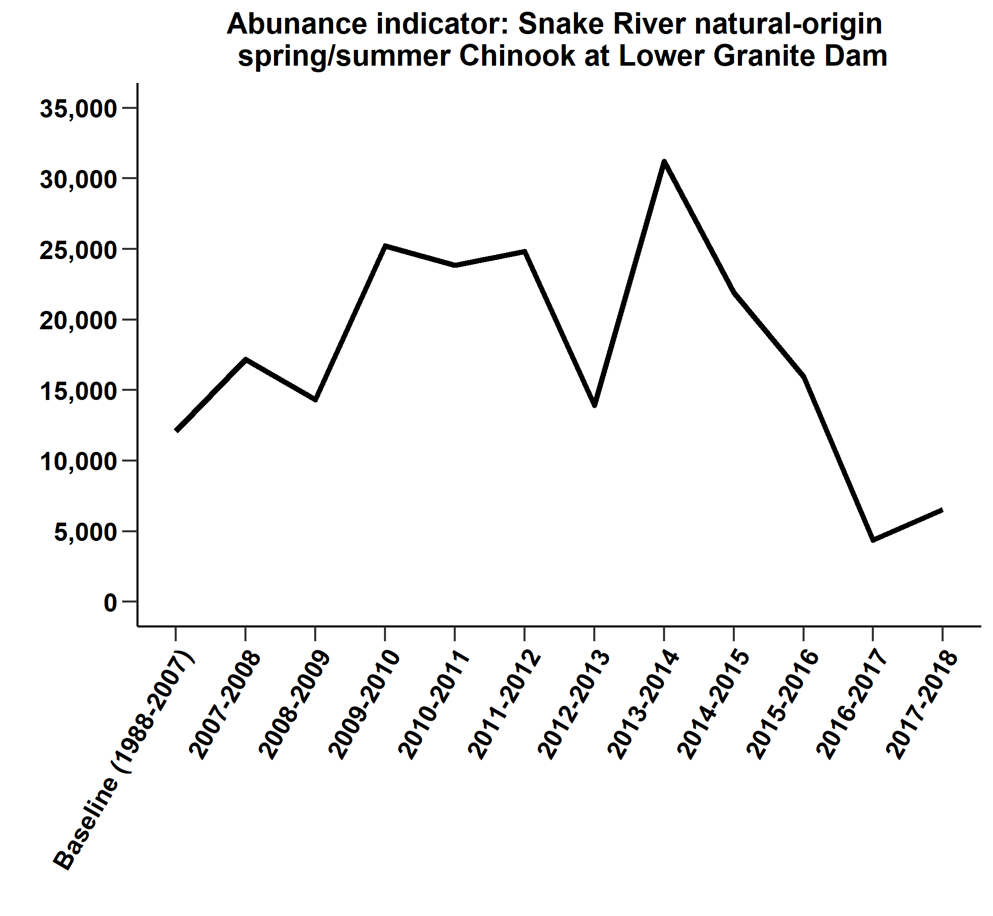

Figure : Natural-origin Snake River spring/summer Chinook.

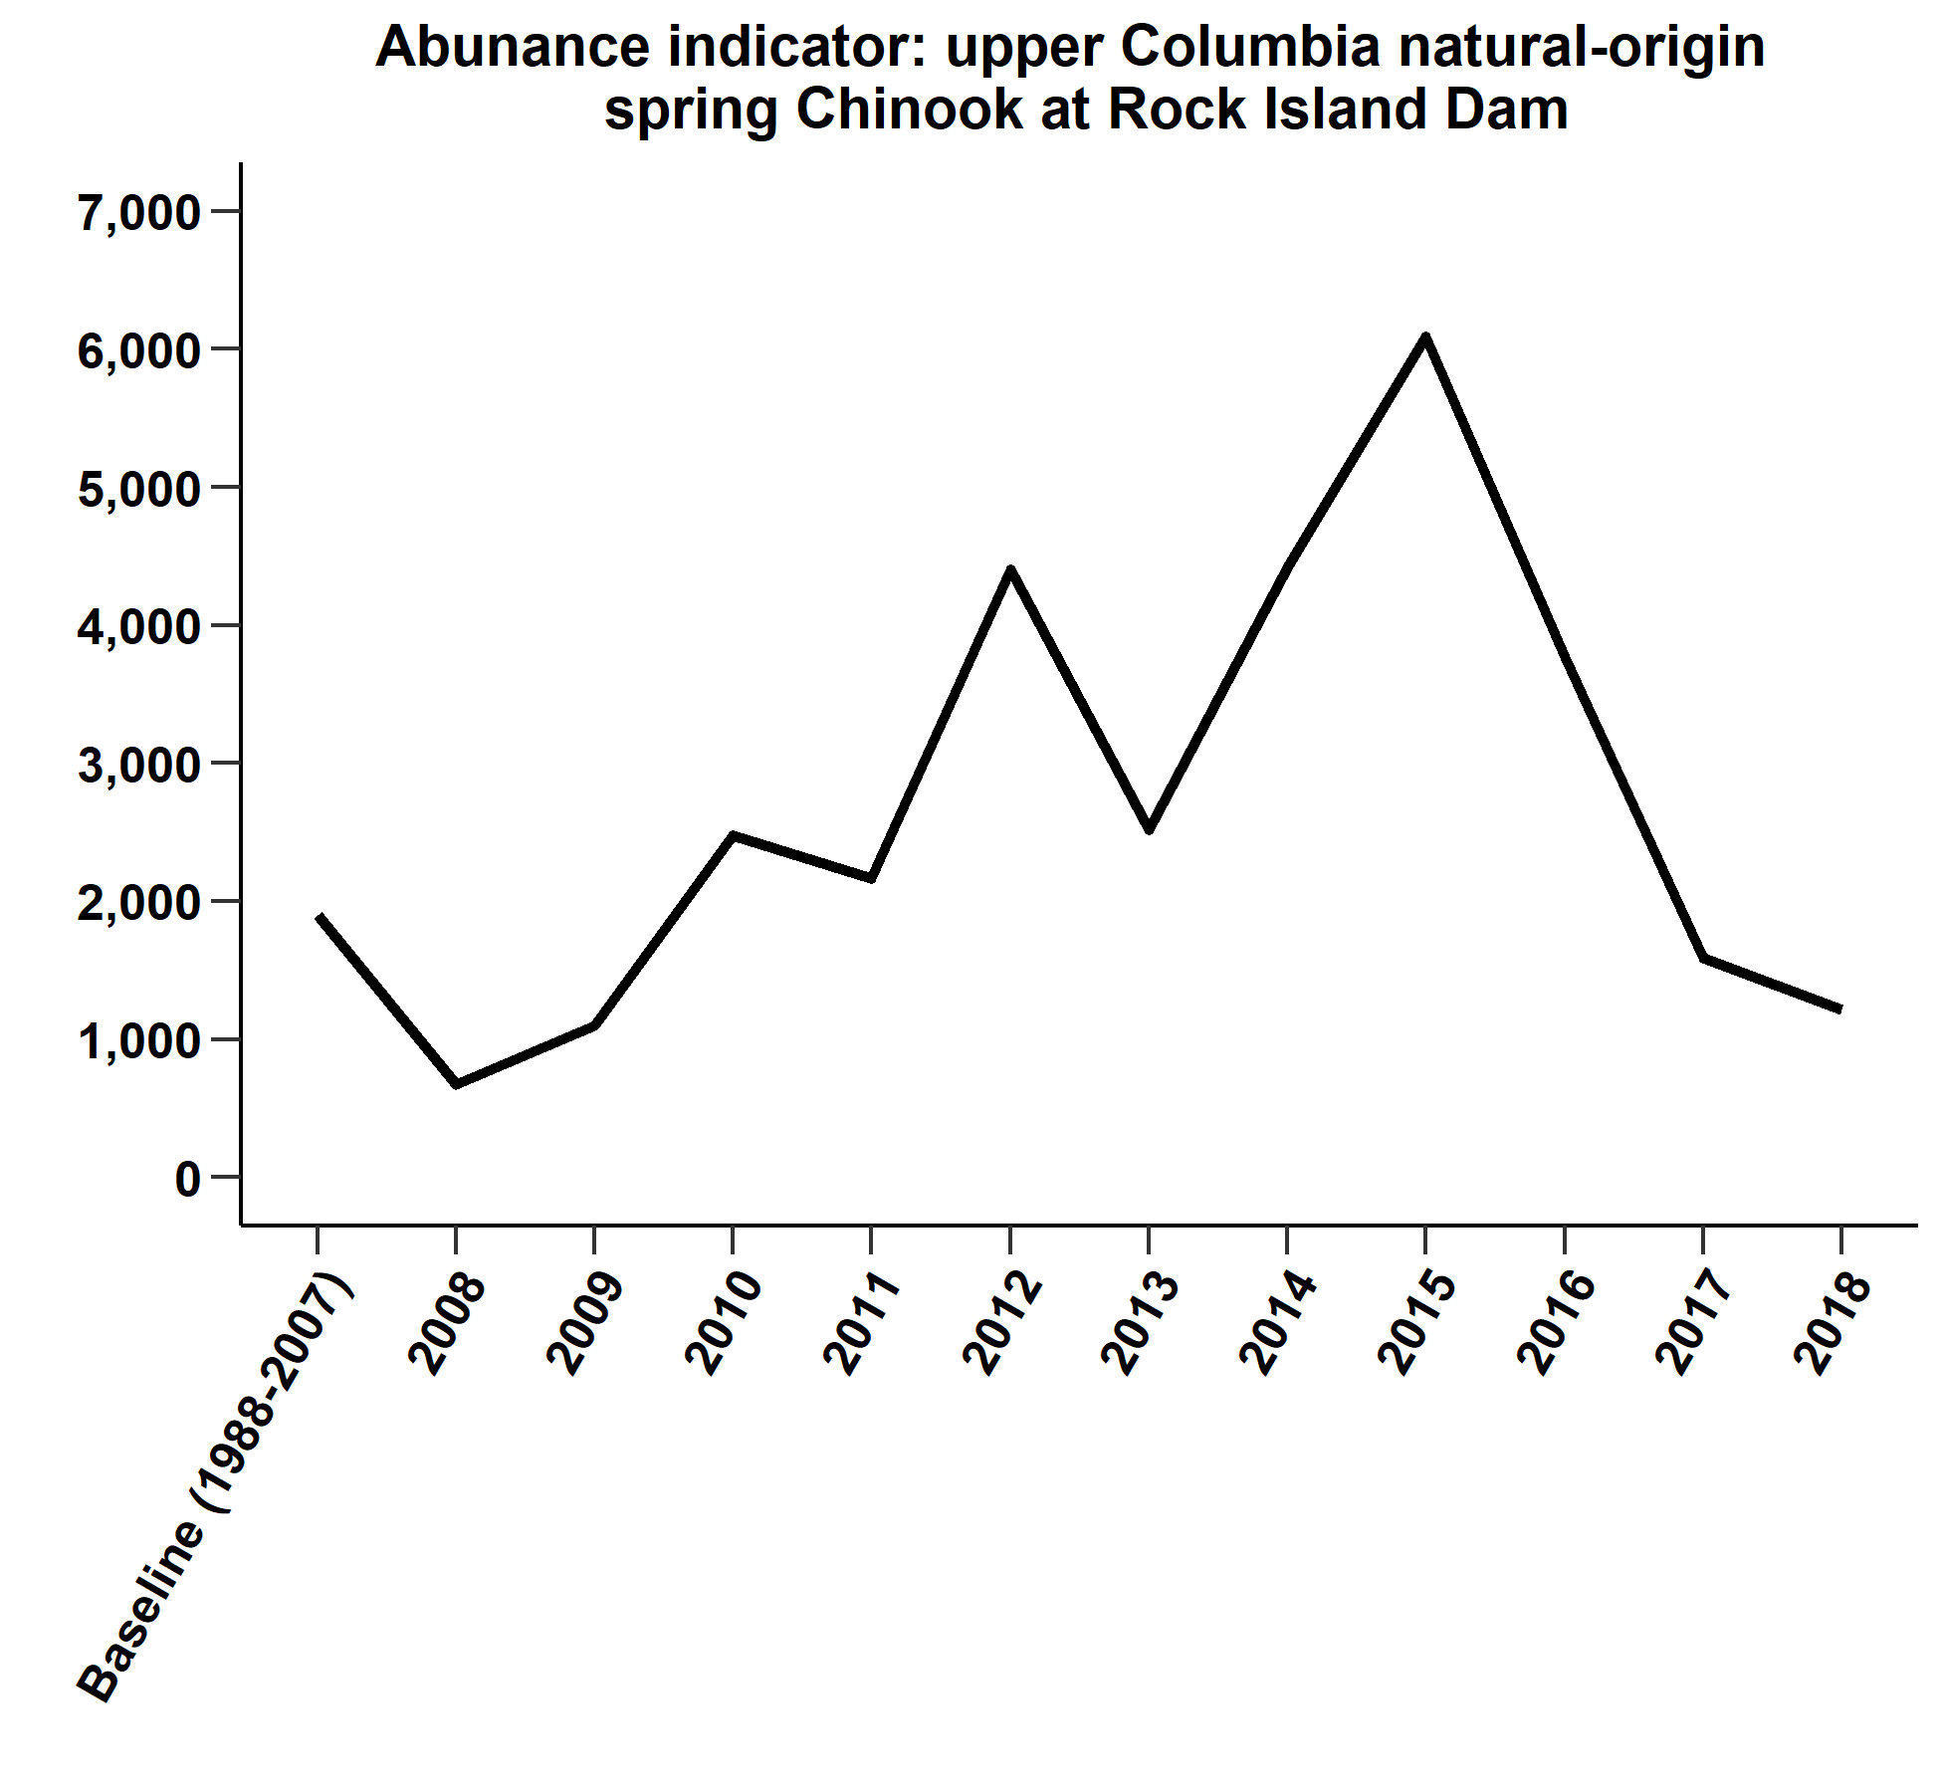

Figure : Natural-origin upper Columbia spring Chinook.

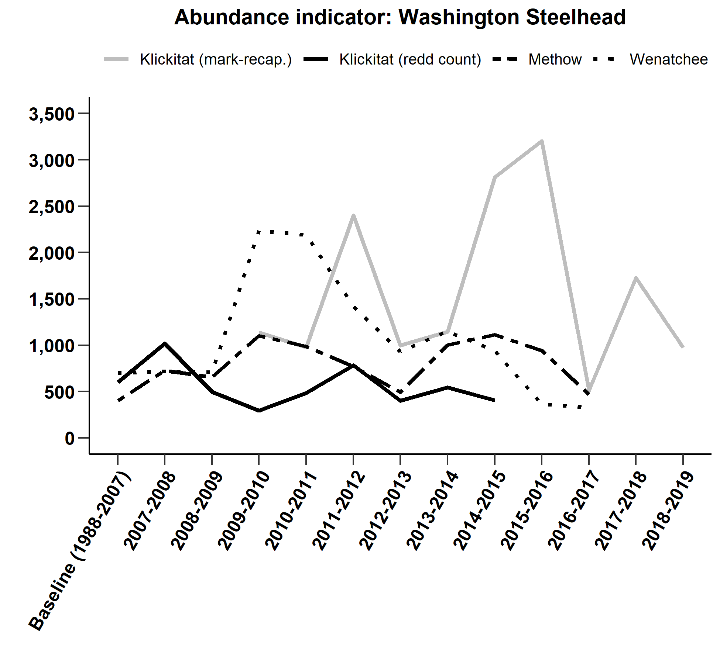

Figure : Natural-origin Washington steelhead.

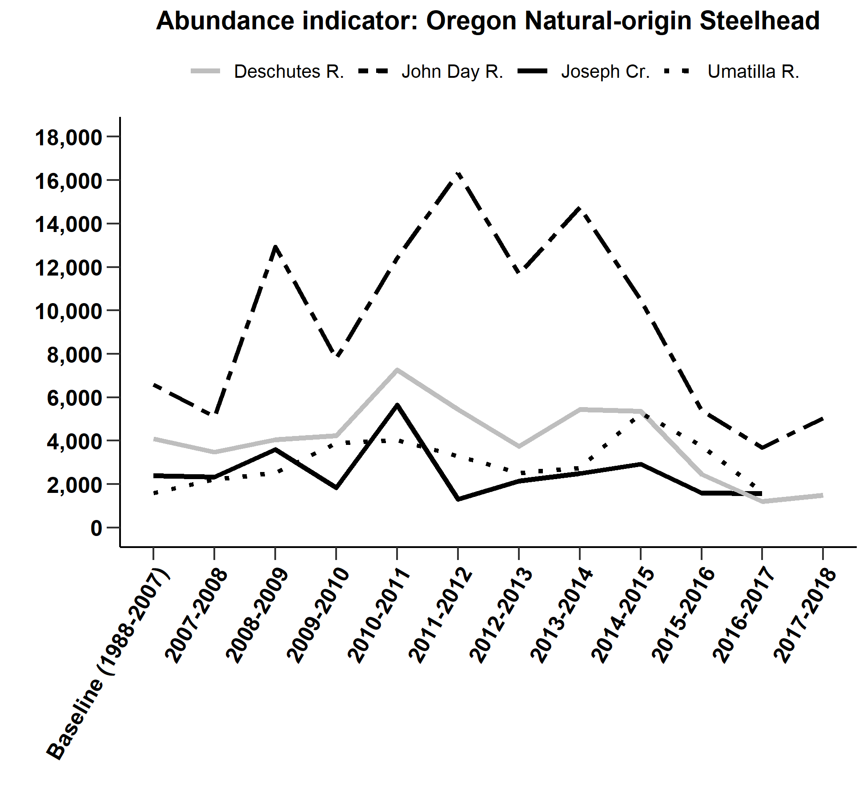

Figure : Natural-origin Oregon tributary steelhead.

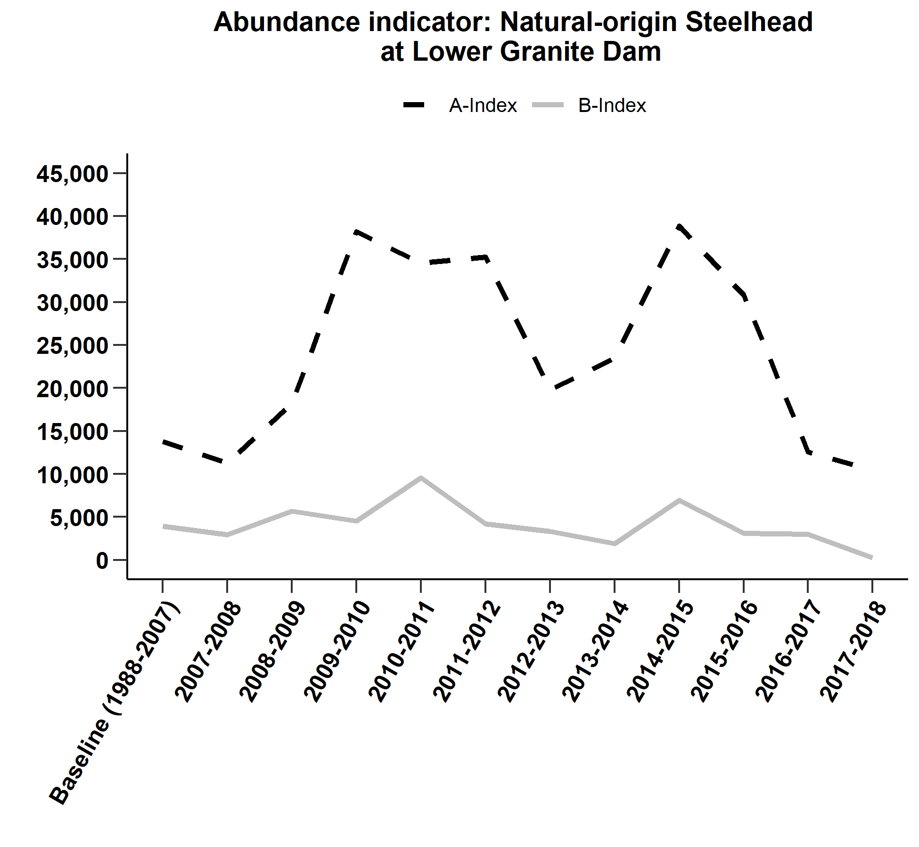

Figure : Natural-origin Snake River steelhead.

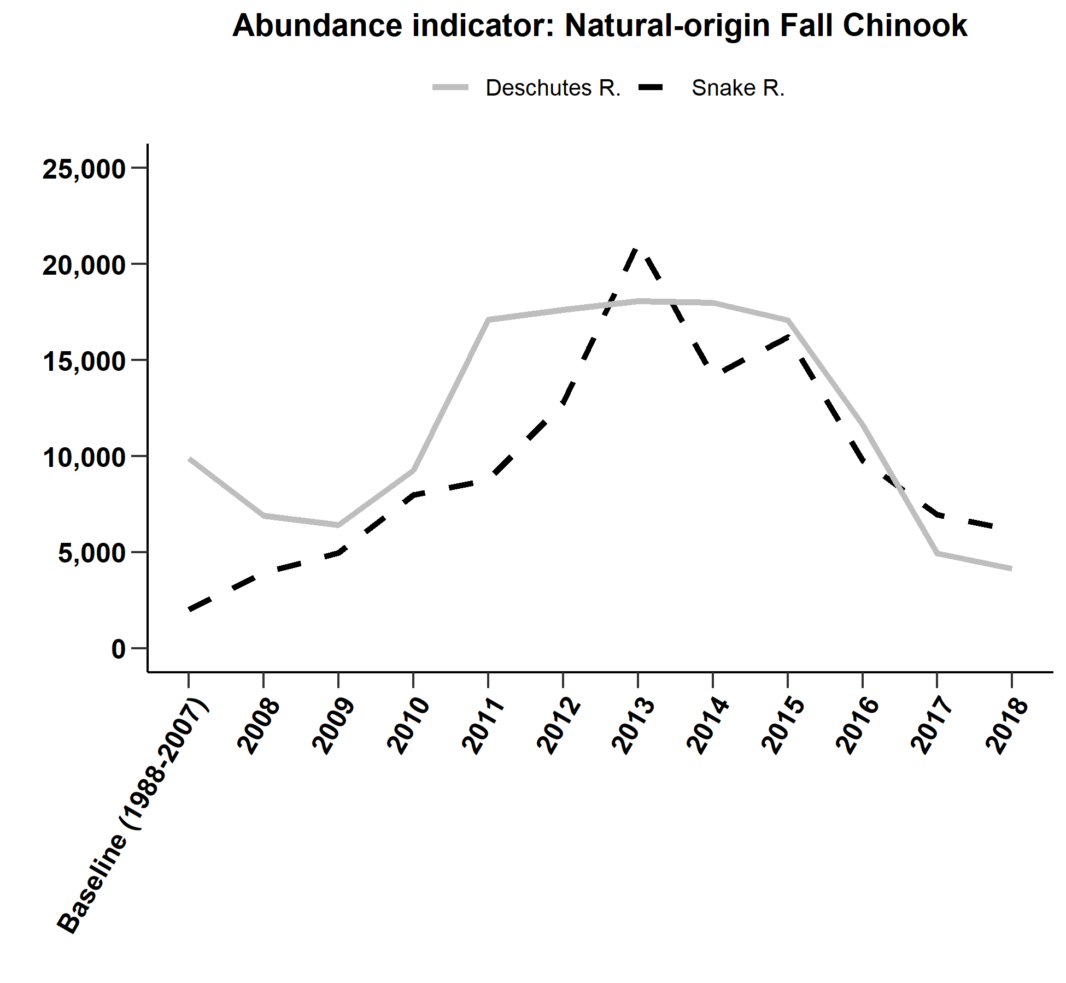

Figure : Natural-origin Snake River steelhead.

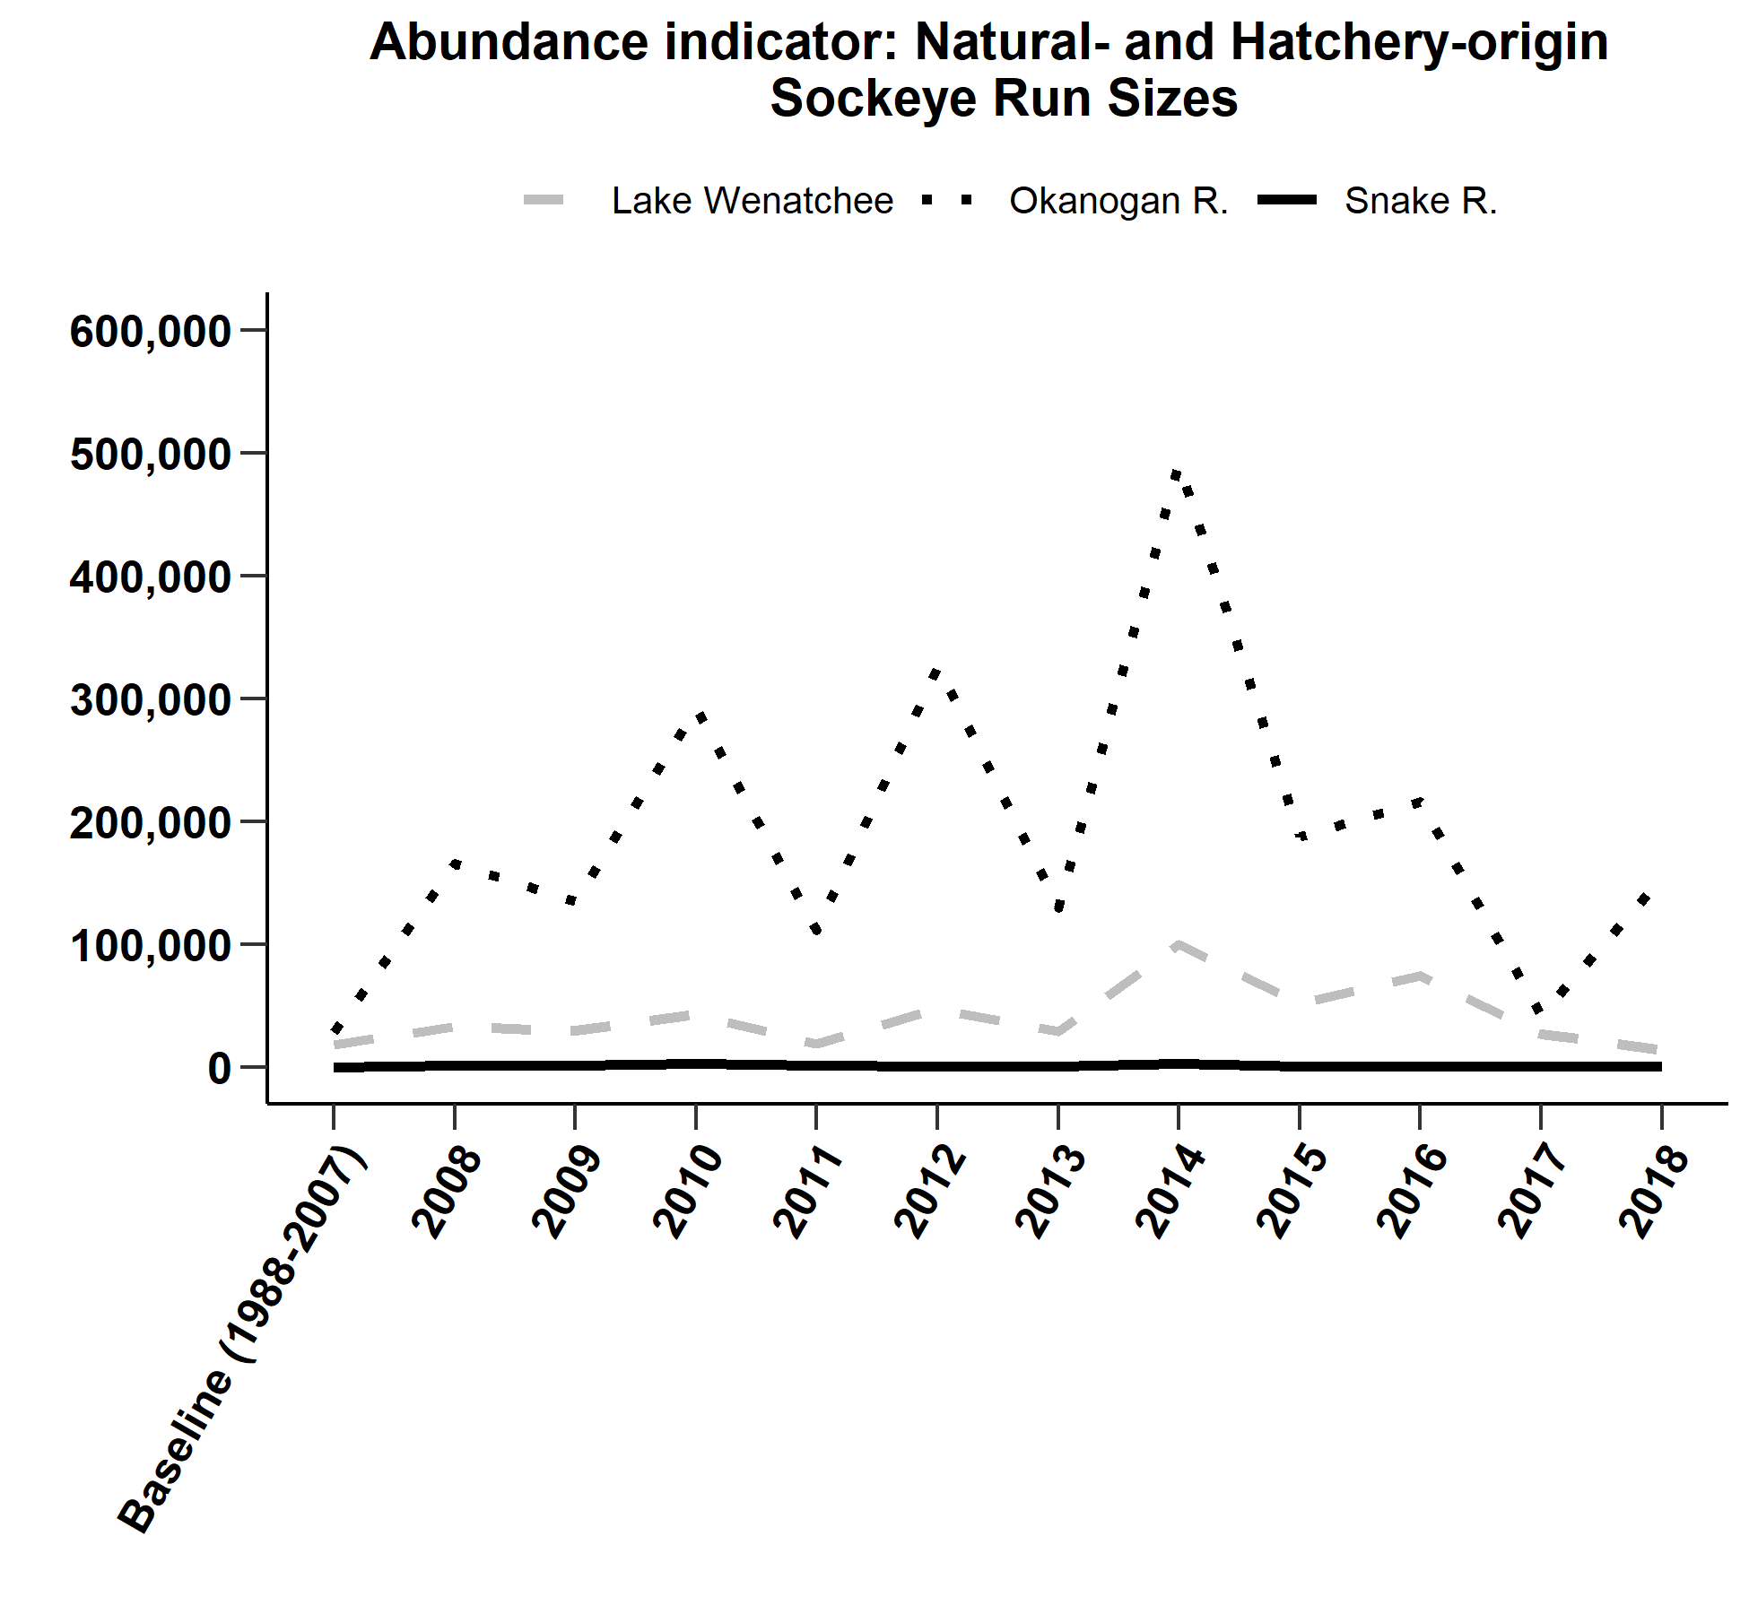

Figure : Natural- and hatchery-origin Sockeye abundance indicators.

1. Fisheries were operated under an extension of the 2008-17 Management Agreement until February 26, 2018 when the 2018-2017 Agreement was filed with the court.
2. For the purposes of this report, ?unclipped and clipped? refer to an adipose fin that is either present or has been removed.
3. 0.8% was the TAC estimate based on the maximum likely effect of non-treaty mark selective fishing in the lower Columbia River.
4. The expected total ESA impacts given the actual level of non-treaty mark selective fishing in the lower Columbia River in 2020 would be slightly above 10.0%.
5. Because there is only a very small amount of treaty steelhead harvest downstream of Bonneville during this time period if any and the harvest occurs just below Bonneville, any treaty catch during this time period will be counted as upriver Skamania stock.
6. Chum research impacts are covered under non-treaty fishery limits.